Date: 27/03/26
📊 Final Count:
🟢 Bullish | 75
🔴 Bearish | 78
Total | 153

🟢 BULLISH TRADES --- 75
1 | ASTRAL
2 | CAMS
3 | HFCL
4 | IEX
5 | NAUKRI
6 | KPITTECH
7 | LICHSGFIN
8 | NHPC
9 | NATIONALUM
10 | ONGC
11 | OFSS
12 | SUNPHARMA
13 | SYNGENE
14 | TATAELXSI
15 | TATATECH
16 | UPL
17 | AUROPHARMA
18 | DMART
19 | BSE
20 | DRREDDY
21 | LUPIN
22 | MCX
23 | NMDC
24 | NTPC
25 | NESTLEIND
26 | SAMMAANCAP
27 | ALKEM
28 | BHARTIARTL
29 | FORTIS
30 | HCLTECH
31 | INFY
32 | MUTHOOTFIN
33 | PERSISTENT
34 | PPLPHARMA
35 | TECHM
36 | TORNTPHARM
37 | AXISBANK
38 | GRASIM
39 | HINDZINC
40 | POWERINDIA
41 | M&M
42 | RVNL
43 | SHREECEM
44 | SRF
45 | ULTRACEMCO
46 | APLAPOLLO
47 | AUBANK
48 | APOLLOHOSP
49 | BAJFINANCE
50 | COFORGE
51 | ETERNAL
52 | HINDPETRO
53 | KALYANKJIL
54 | LT
55 | MANKIND
56 | MAXHEALTH
57 | OBEROIRLTY
58 | TATASTEEL
59 | GLENMARK
60 | PNBHOUSING
61 | FEDERALBNK
62 | DALBHARAT
63 | LTM
64 | MARICO
65 | MPHASIS
66 | VOLTAS
67 | DELHIVERY
68 | KAYNES
69 | TIINDIA
70 | ANGELONE
71 | JINDALSTEL
72 | LAURUSLABS
73 | NUVAMA
74 | WIPRO
75 | FEDERALBNK
🔴 BEARISH TRADES --- 78
1 | BDL
2 | COALINDIA
3 | GAIL
4 | LODHA
5 | PETRONET
6 | SBILIFE
7 | DIVISLAB
8 | CYIENT
9 | BEL
10 | GODREJCP
11 | MAZDOCK
12 | TORNTPOWER
13 | IDEA
14 | ABB
15 | BOSCHLTD
16 | HAL
17 | IGL
18 | TATAPOWER
19 | ADANIGREEN
20 | ABCAPITAL
21 | BANDHANBNK
22 | BANKINDIA
23 | CDSL
24 | DLF
25 | GMRAIRPORT
26 | IIFL
27 | INDUSINDBK
28 | INDIGO
29 | JIOFIN
30 | KOTAKBANK
31 | LTF
32 | M&M
33 | MCX
34 | PFC
35 | RBLBANK
36 | RECLTD
37 | SHRIRAMFIN
38 | TATACONSUM
39 | TVSMOTOR
40 | UNIONBANK
41 | BHEL
42 | CANBK
43 | CHOLAFIN
44 | INDIANB
45 | IRFC
46 | POLYCAB
47 | PRESTIGE
48 | PHOENIXLTD
49 | VEDL
50 | AMBUJACEM
51 | BLUESTARCO
52 | HDFCAMC
53 | MANAPPURAM
54 | MOTHERSON
55 | SUZLON
56 | YESBANK
57 | BAJAJ-AUTO
58 | BIOCON
59 | NYKAA
60 | IDFCFIRSTB
61 | POWERGRID
62 | SBICARD
63 | EICHERMOT
64 | HDFCBANK
65 | HUDCO
66 | SONACOMS
67 | UNOMINDA
68 | 360ONE
69 | COLPAL
70 | CONCOR
71 | ICICIGI
72 | ICICIPRULI
73 | IRCTC
74 | MARUTI
75 | MFSL
76 | NCC
77 | SAIL
78 | TMPV

Trade Taken
🟢 BULLISH SIGNAL --- NAUKRI

Nifty Bias : 🔴 SHORT — Counter Trend ⚠️
Crossover : 2026-03-24 12:00 (3 days ago)
Pullback : 2026-03-25 14:45
Low ₹999 ≤ EMA9(Low) ₹1003.67
High ₹1002.1 (breakout level)
Confirm : 2026-03-27 09:15 (+3 candle)
Close ₹1005.3 > Pullback High ₹1002.1 (body breakout)
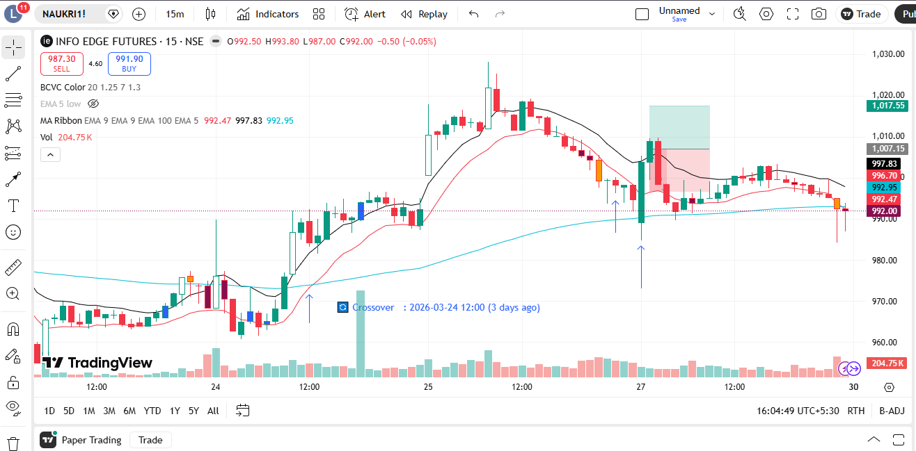
🔴 BEARISH SIGNAL --- LODHA

Nifty Bias : 🔴 SHORT — Aligned ✅
Crossover : 2026-03-19 09:30 (8 days ago)
Pullback : 2026-03-25 15:15
High ₹741.85 ≥ EMA9(High) ₹741.16
Low ₹725.1 (breakdown level)
Confirm : 2026-03-27 09:15 (+1 candle)
Close ₹723.7 < Pullback Low ₹725.1 (body breakdown)
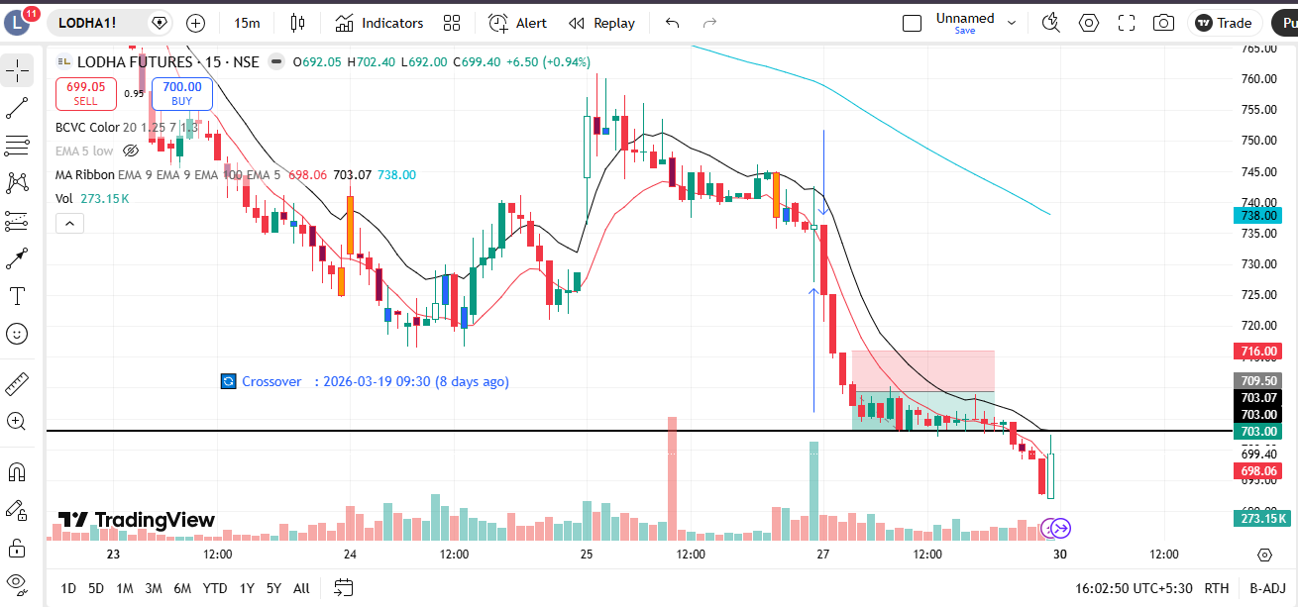
🔴 BEARISH SIGNAL --- PETRONET

Nifty Bias : 🔴 SHORT — Aligned ✅
Crossover : 2026-03-19 09:45 (8 days ago)
Pullback : 2026-03-25 15:15
High ₹251 ≥ EMA9(High) ₹250.17
Low ₹249.35 (breakdown level)
Confirm : 2026-03-27 09:45 (+3 candle)
Close ₹248.4 < Pullback Low ₹249.35 (body breakdown)
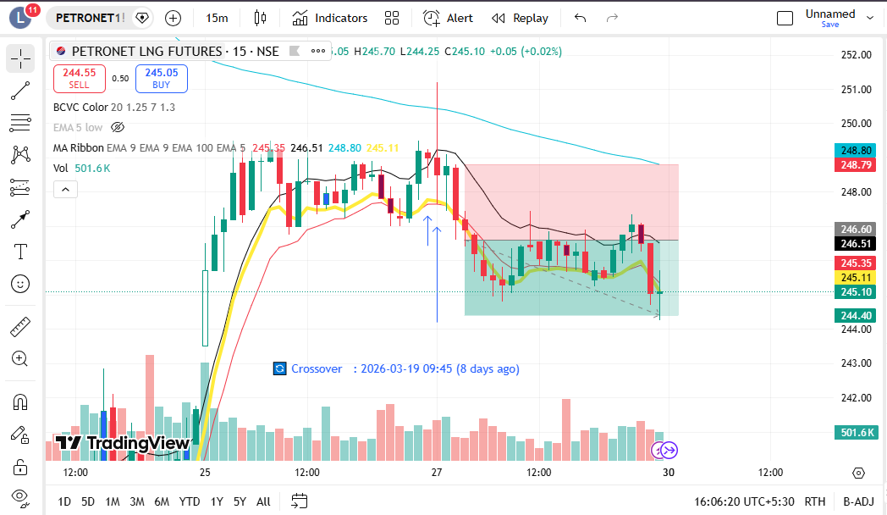
🔴 BEARISH SIGNAL --- DIVISLAB

Nifty Bias : 🔴 SHORT — Aligned ✅
Crossover : 2026-03-25 15:15 (2 days ago)
Pullback : 2026-03-27 11:00
High ₹6052 ≥ EMA9(High) ₹6030.96
Low ₹6022.5 (breakdown level)
Confirm : 2026-03-27 11:15 (+1 candle)
Close ₹6008.5 < Pullback Low ₹6022.5 (body breakdown)
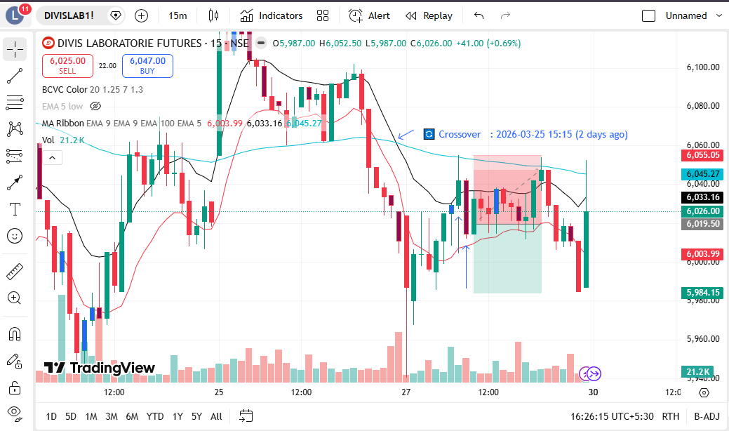
🔴 BEARISH SIGNAL --- BEL

Nifty Bias : 🔴 SHORT — Aligned ✅
Crossover : 2026-03-19 10:00 (8 days ago)
Pullback : 2026-03-27 12:00
High ₹413.45 ≥ EMA9(High) ₹411.47
Low ₹412.45 (breakdown level)
Confirm : 2026-03-27 12:15 (+1 candle)
Close ₹411.7 < Pullback Low ₹412.45 (body breakdown)
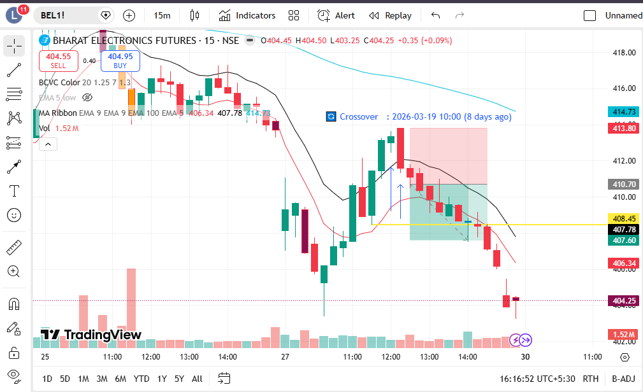
🔴 BEARISH SIGNAL --- MAZDOCK

Nifty Bias : 🔴 SHORT — Aligned ✅
Crossover : 2026-03-25 14:30 (2 days ago)
Pullback : 2026-03-27 12:30
High ₹2228 ≥ EMA9(High) ₹2213.83
Low ₹2214.1 (breakdown level)
Confirm : 2026-03-27 12:45 (+1 candle)
Close ₹2210.8 < Pullback Low ₹2214.1 (body breakdown)
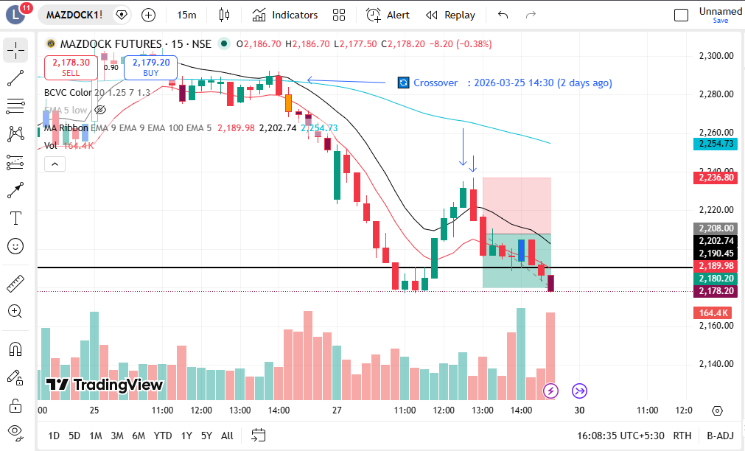
🔴 BEARISH SIGNAL --- TORNTPOWER

Nifty Bias : 🔴 SHORT — Aligned ✅
Crossover : 2026-03-25 15:00 (2 days ago)
Pullback : 2026-03-27 12:30
High ₹1391.8 ≥ EMA9(High) ₹1387.69
Low ₹1384.8 (breakdown level)
Confirm : 2026-03-27 12:45 (+1 candle)
Close ₹1384.2 < Pullback Low ₹1384.8 (body breakdown)
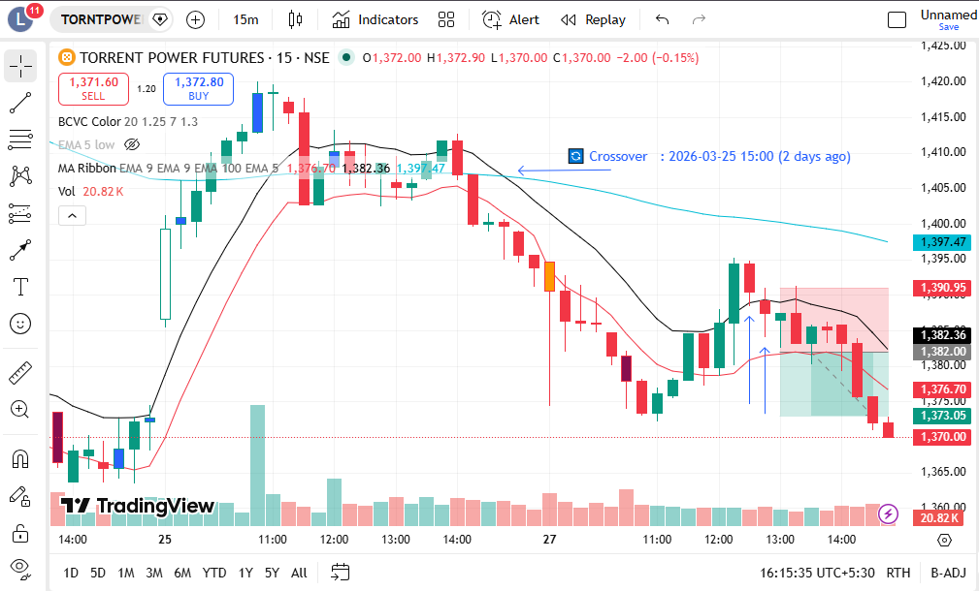
🔴 BEARISH SIGNAL --- MCX

Nifty Bias : 🔴 SHORT — Aligned ✅
Crossover : 2026-03-27 12:15 (2 hours ago)
Pullback : 2026-03-27 13:15
High ₹2423.5 ≥ EMA9(High) ₹2423.22
Low ₹2411.3 (breakdown level)
Confirm : 2026-03-27 13:30 (+1 candle)
Close ₹2407.5 < Pullback Low ₹2411.3 (body breakdown)
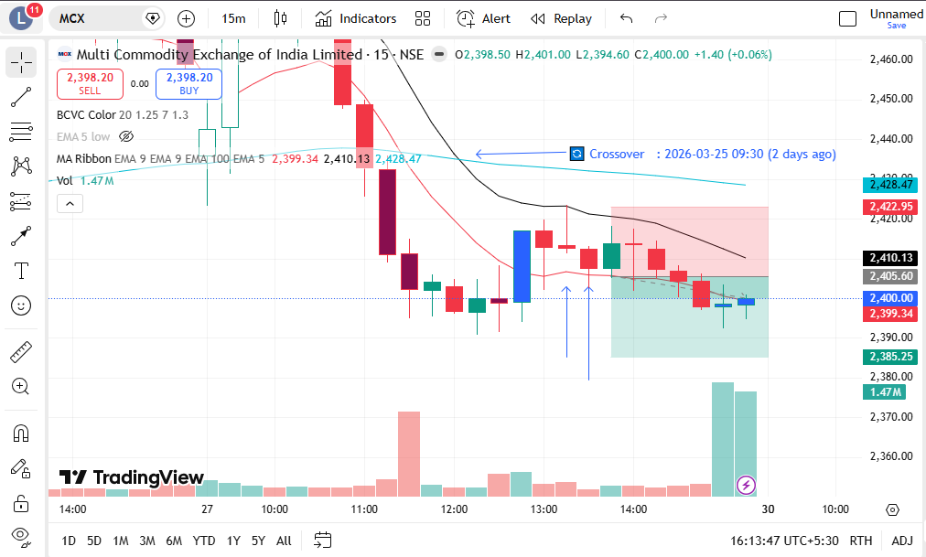

Trade Not Taken
🟢 BULLISH SIGNAL --- ASTRAL

Nifty Bias : 🔴 SHORT — Counter Trend ⚠️
Crossover : 2026-03-25 09:30 (2 days ago)
Pullback : 2026-03-25 15:15
Low ₹1642.2 ≤ EMA9(Low) ₹1649.52
High ₹1648.5 (breakout level)
Confirm : 2026-03-27 09:15 (+1 candle)
Close ₹1649.4 > Pullback High ₹1648.5 (body breakout)
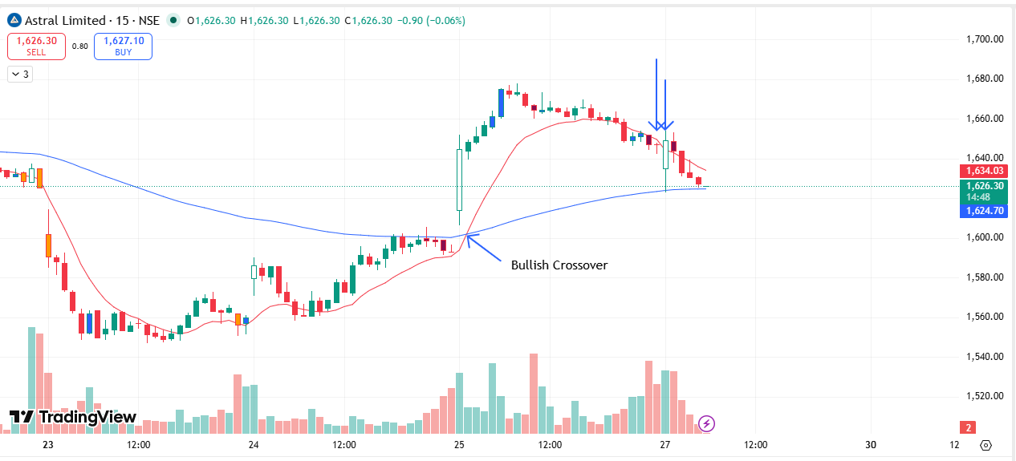
🟢 BULLISH SIGNAL --- CAMS

Nifty Bias : 🔴 SHORT — Counter Trend ⚠️
Crossover : 2026-03-24 13:45 (3 days ago)
Pullback : 2026-03-25 15:00
Low ₹643.3 ≤ EMA9(Low) ₹646.71
High ₹647.05 (breakout level)
Confirm : 2026-03-27 09:15 (+2 candle)
Close ₹647.9 > Pullback High ₹647.05 (body breakout)
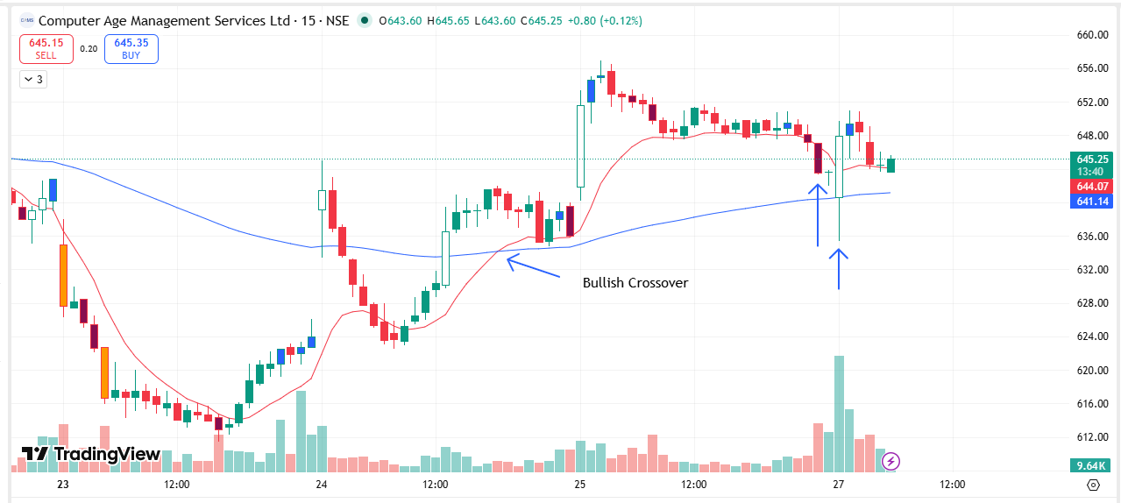
🟢 BULLISH SIGNAL --- HFCL

Nifty Bias : 🔴 SHORT — Counter Trend ⚠️
Crossover : 2026-03-25 09:30 (2 days ago)
Pullback : 2026-03-25 14:45
Low ₹71.1 ≤ EMA9(Low) ₹71.33
High ₹71.55 (breakout level)
Confirm : 2026-03-27 09:15 (+3 candle)
Close ₹72.84 > Pullback High ₹71.55 (body breakout)
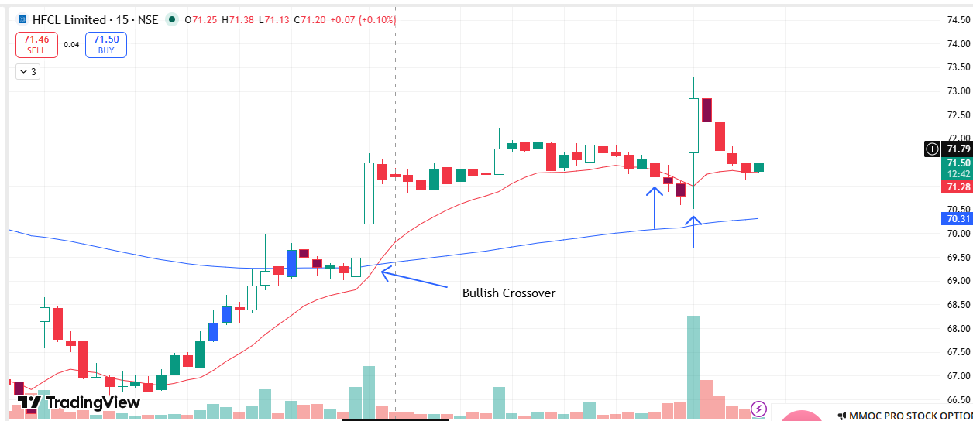
🟢 BULLISH SIGNAL --- IEX

Nifty Bias : 🔴 SHORT — Counter Trend ⚠️
Crossover : 2026-03-24 14:45 (3 days ago)
Pullback : 2026-03-25 15:00
Low ₹121.37 ≤ EMA9(Low) ₹121.9
High ₹121.94 (breakout level)
Confirm : 2026-03-27 09:15 (+2 candle)
Close ₹122.14 > Pullback High ₹121.94 (body breakout)
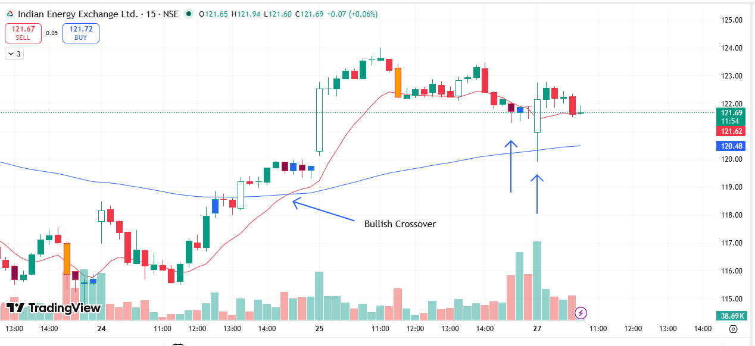
🟢 BULLISH SIGNAL --- KPITTECH

Nifty Bias : 🔴 SHORT — Counter Trend ⚠️
Crossover : 2026-03-24 13:30 (3 days ago)
Pullback : 2026-03-25 14:45
Low ₹674.35 ≤ EMA9(Low) ₹675.84
High ₹677.4 (breakout level)
Confirm : 2026-03-27 09:15 (+3 candle)
Close ₹678.75 > Pullback High ₹677.4 (body breakout)
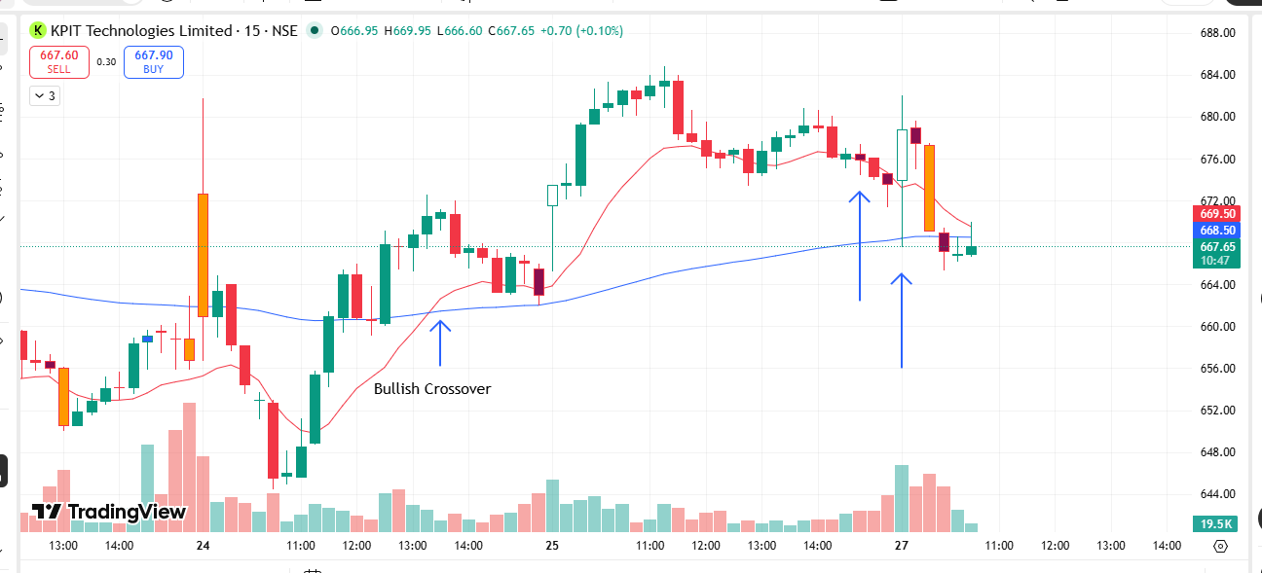
🟢 BULLISH SIGNAL --- LICHSGFIN

Nifty Bias : 🔴 SHORT — Counter Trend ⚠️
Crossover : 2026-03-25 09:30 (2 days ago)
Pullback : 2026-03-25 14:45
Low ₹496 ≤ EMA9(Low) ₹496.28
High ₹497.65 (breakout level)
Confirm : 2026-03-27 09:15 (+3 candle)
Close ₹508.1 > Pullback High ₹497.65 (body breakout)
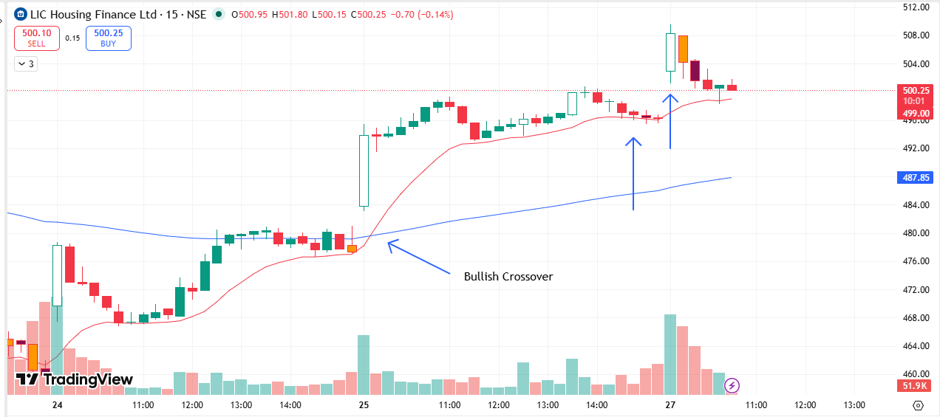
🟢 BULLISH SIGNAL --- NHPC

Nifty Bias : 🔴 SHORT — Counter Trend ⚠️
Crossover : 2026-03-24 15:15 (3 days ago)
Pullback : 2026-03-25 14:45
Low ₹77.14 ≤ EMA9(Low) ₹77.64
High ₹77.77 (breakout level)
Confirm : 2026-03-27 09:15 (+3 candle)
Close ₹77.96 > Pullback High ₹77.77 (body breakout)
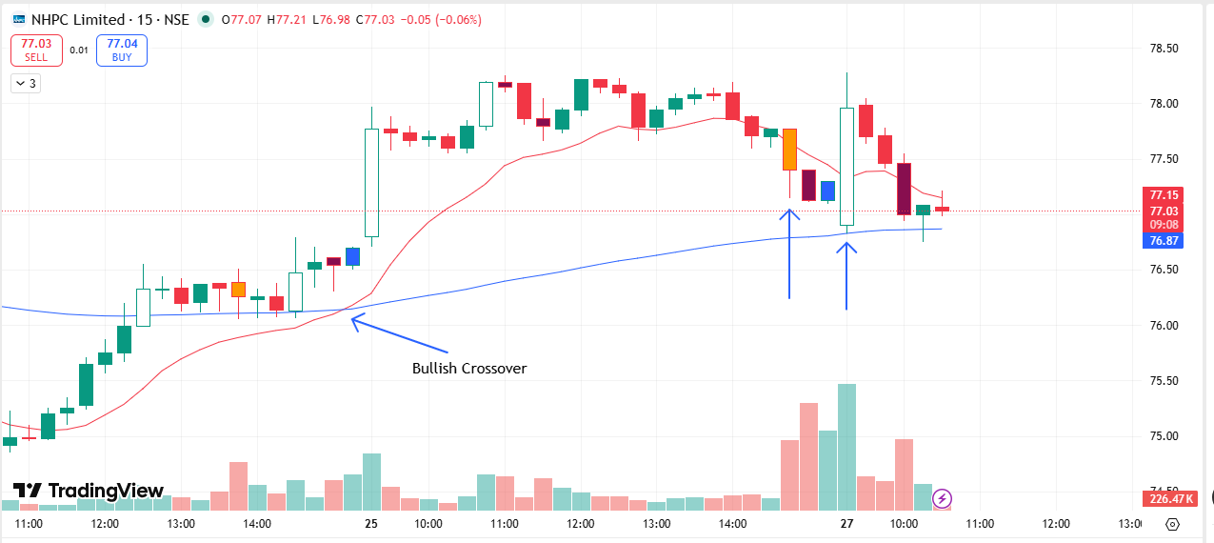
🟢 BULLISH SIGNAL --- NATIONALUM

Nifty Bias : 🔴 SHORT — Counter Trend ⚠️
Crossover : 2026-03-25 11:45 (2 days ago)
Pullback : 2026-03-25 15:00
Low ₹366.45 ≤ EMA9(Low) ₹366.51
High ₹368.1 (breakout level)
Confirm : 2026-03-27 09:15 (+2 candle)
Close ₹369 > Pullback High ₹368.1 (body breakout)
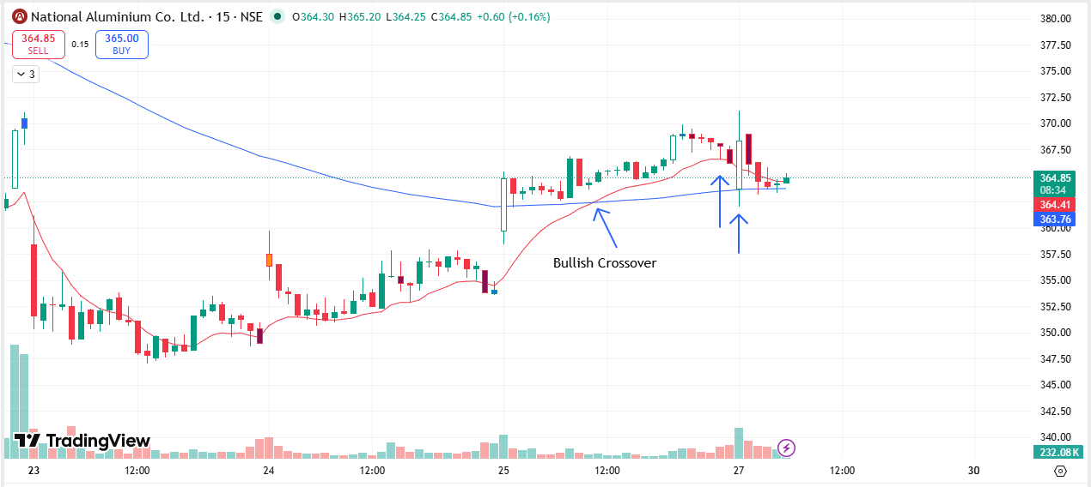
🟢 BULLISH SIGNAL --- ONGC

Nifty Bias : 🔴 SHORT — Counter Trend ⚠️
Crossover : 2026-03-25 10:30 (2 days ago)
Pullback : 2026-03-25 14:45
Low ₹269.65 ≤ EMA9(Low) ₹269.95
High ₹270.3 (breakout level)
Confirm : 2026-03-27 09:15 (+3 candle)
Close ₹275.4 > Pullback High ₹270.3 (body breakout)
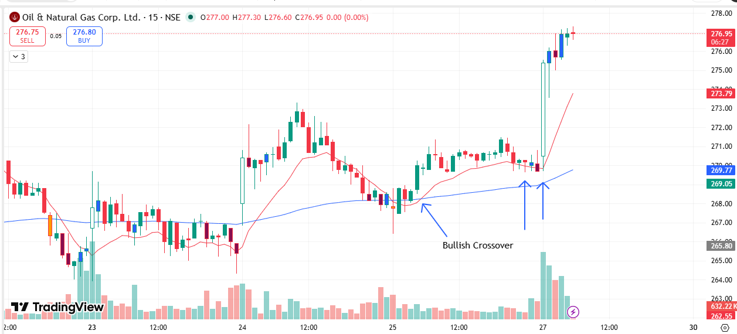

🟢 BULLISH SIGNAL --- OFSS

Nifty Bias : 🔴 SHORT — Counter Trend ⚠️
Crossover : 2026-03-24 12:00 (3 days ago)
Pullback : 2026-03-25 14:45
Low ₹6610 ≤ EMA9(Low) ₹6628.55
High ₹6641.5 (breakout level)
Confirm : 2026-03-27 09:15 (+3 candle)
Close ₹7014.5 > Pullback High ₹6641.5 (body breakout)
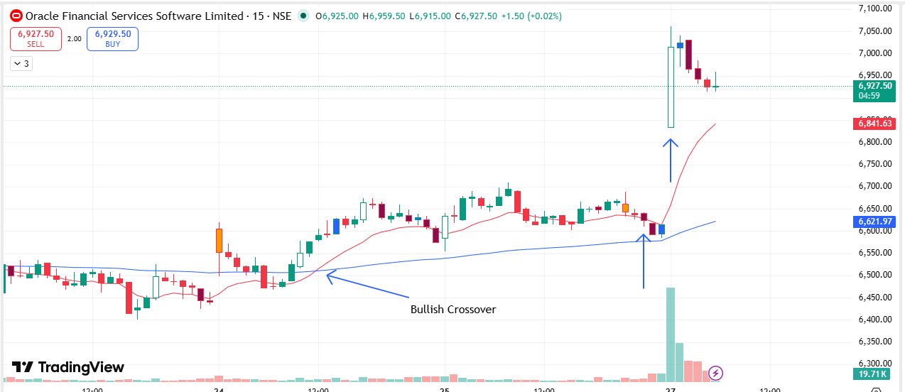
🟢 BULLISH SIGNAL --- SUNPHARMA

Nifty Bias : 🔴 SHORT — Counter Trend ⚠️
Crossover : 2026-03-25 11:00 (2 days ago)
Pullback : 2026-03-25 15:15
Low ₹1793.4 ≤ EMA9(Low) ₹1794.42
High ₹1800 (breakout level)
Confirm : 2026-03-27 09:15 (+1 candle)
Close ₹1801.3 > Pullback High ₹1800 (body breakout)
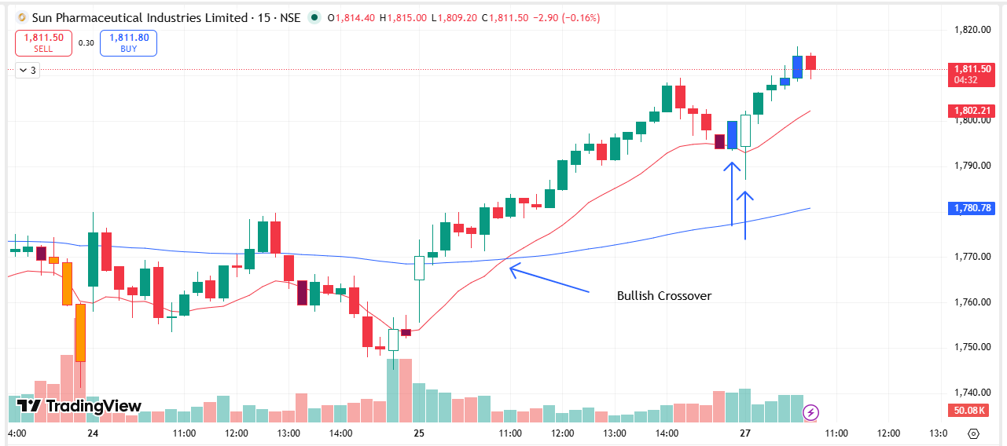
🟢 BULLISH SIGNAL --- SYNGENE

Nifty Bias : 🔴 SHORT — Counter Trend ⚠️
Crossover : 2026-03-25 10:00 (2 days ago)
Pullback : 2026-03-25 14:45
Low ₹418.25 ≤ EMA9(Low) ₹419.57
High ₹420.4 (breakout level)
Confirm : 2026-03-27 09:15 (+3 candle)
Close ₹425.25 > Pullback High ₹420.4 (body breakout)
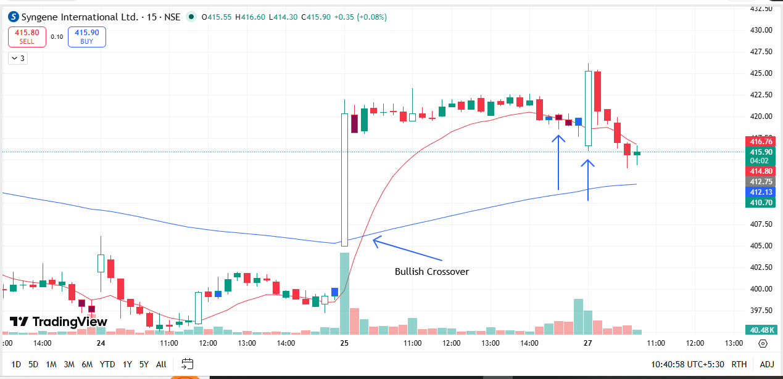
🟢 BULLISH SIGNAL --- TATAELXSI

Nifty Bias : 🔴 SHORT — Counter Trend ⚠️
Crossover : 2026-03-25 09:30 (2 days ago)
Pullback : 2026-03-25 14:45
Low ₹4223.6 ≤ EMA9(Low) ₹4236.76
High ₹4237.8 (breakout level)
Confirm : 2026-03-27 09:15 (+3 candle)
Close ₹4252 > Pullback High ₹4237.8 (body breakout)
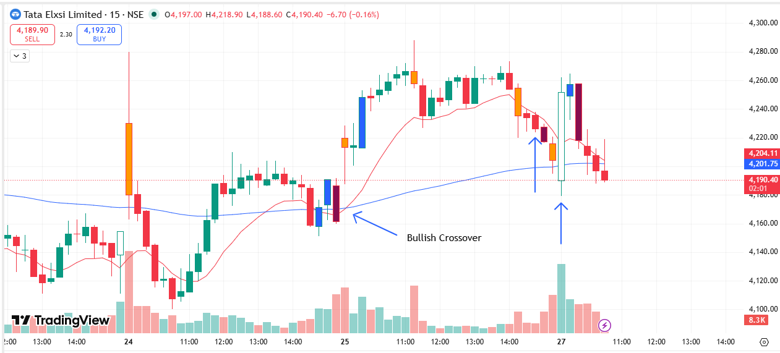
🟢 BULLISH SIGNAL --- TATATECH

Nifty Bias : 🔴 SHORT — Counter Trend ⚠️
Crossover : 2026-03-25 09:30 (2 days ago)
Pullback : 2026-03-25 14:45
Low ₹544.1 ≤ EMA9(Low) ₹545.2
High ₹546.4 (breakout level)
Confirm : 2026-03-27 09:15 (+3 candle)
Close ₹551.2 > Pullback High ₹546.4 (body breakout)
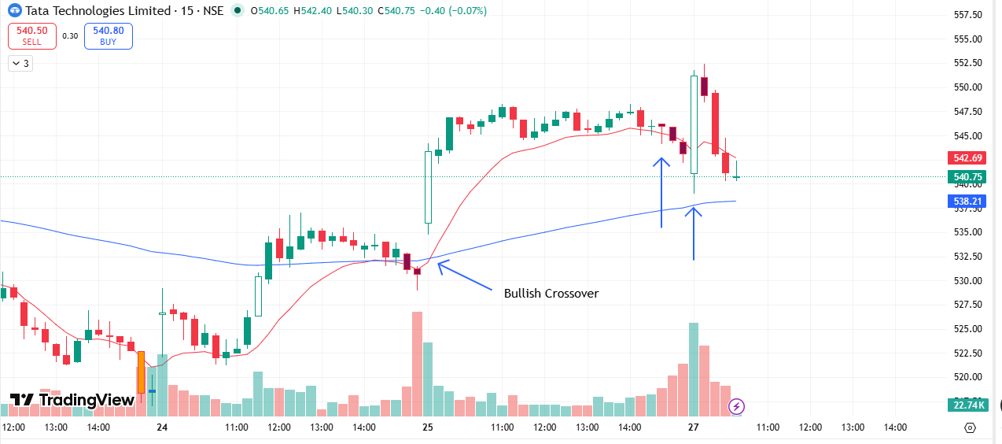
🟢 BULLISH SIGNAL --- UPL

Nifty Bias : 🔴 SHORT — Counter Trend ⚠️
Crossover : 2026-03-24 13:30 (3 days ago)
Pullback : 2026-03-25 15:15
Low ₹622.95 ≤ EMA9(Low) ₹623.86
High ₹626.6 (breakout level)
Confirm : 2026-03-27 09:15 (+1 candle)
Close ₹628.4 > Pullback High ₹626.6 (body breakout)
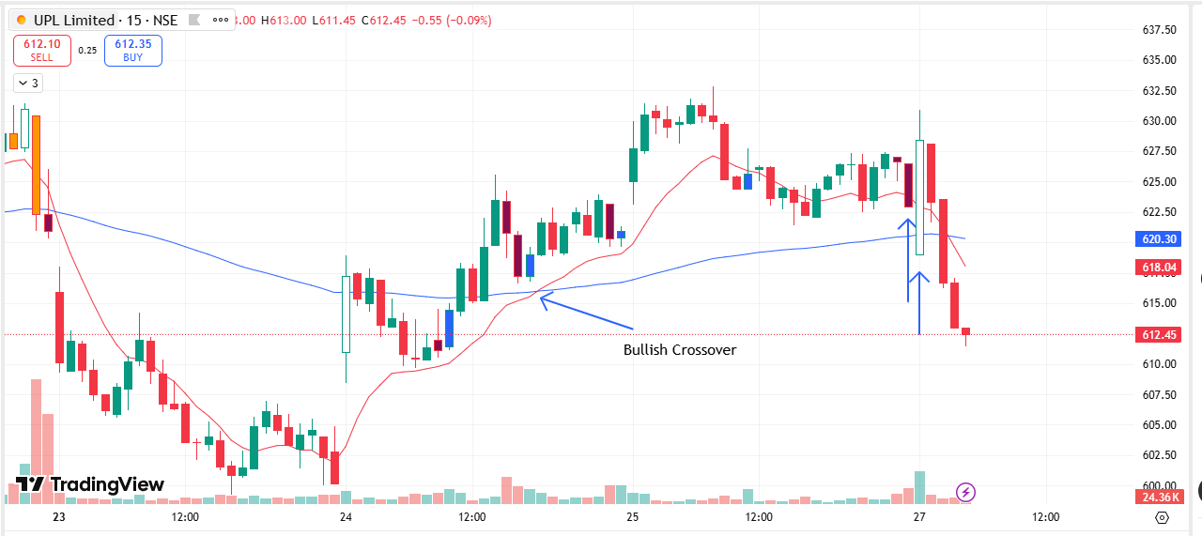
🟢 BULLISH SIGNAL --- AUROPHARMA

Nifty Bias : 🔴 SHORT — Counter Trend ⚠️
Crossover : 2026-03-24 15:00 (3 days ago)
Pullback : 2026-03-25 15:00
Low ₹1305.1 ≤ EMA9(Low) ₹1310.27
High ₹1310.2 (breakout level)
Confirm : 2026-03-27 09:30 (+3 candle)
Close ₹1317.9 > Pullback High ₹1310.2 (body breakout)
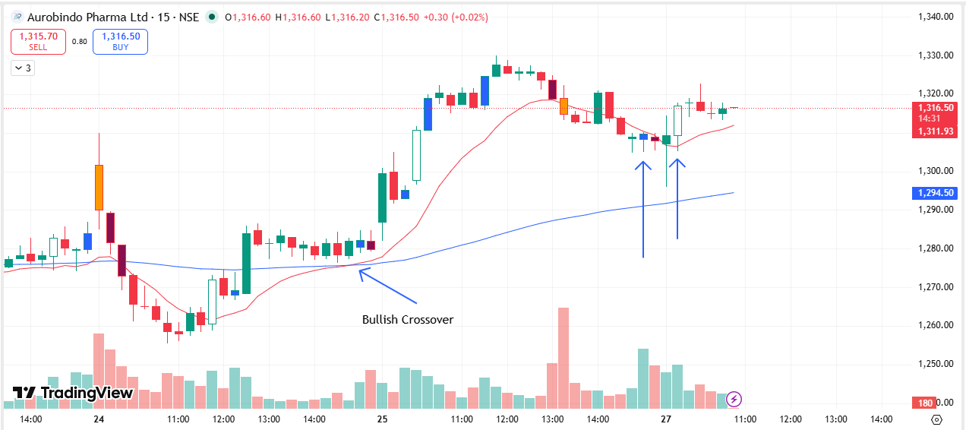
🟢 BULLISH SIGNAL --- DMART

Nifty Bias : 🔴 SHORT — Counter Trend ⚠️
Crossover : 2026-03-25 09:30 (2 days ago)
Pullback : 2026-03-27 09:15
Low ₹3865.5 ≤ EMA9(Low) ₹3895.57
High ₹3915.9 (breakout level)
Confirm : 2026-03-27 09:30 (+1 candle)
Close ₹3931.9 > Pullback High ₹3915.9 (body breakout)
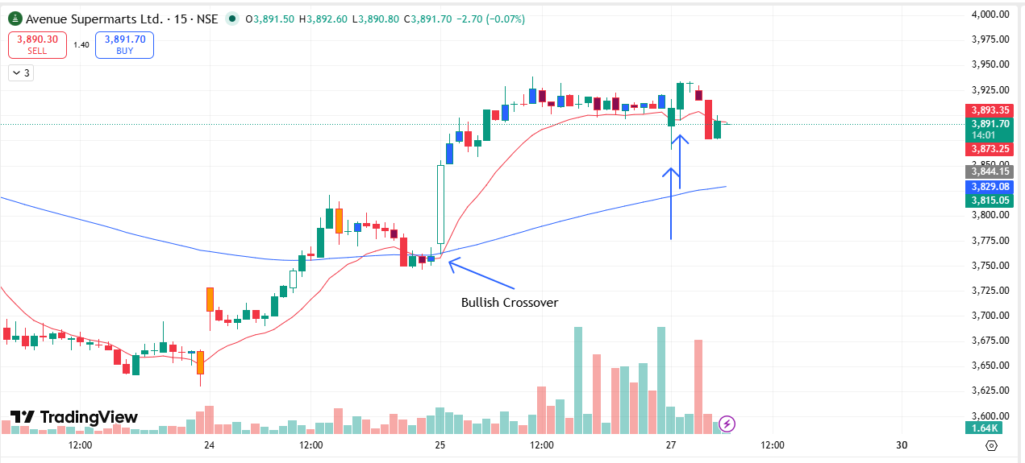
🟢 BULLISH SIGNAL --- BSE

Nifty Bias : 🔴 SHORT — Counter Trend ⚠️
Crossover : 2026-03-25 09:30 (2 days ago)
Pullback : 2026-03-27 09:15
Low ₹2840 ≤ EMA9(Low) ₹2872.26
High ₹2868.1 (breakout level)
Confirm : 2026-03-27 09:30 (+1 candle)
Close ₹2870 > Pullback High ₹2868.1 (body breakout)
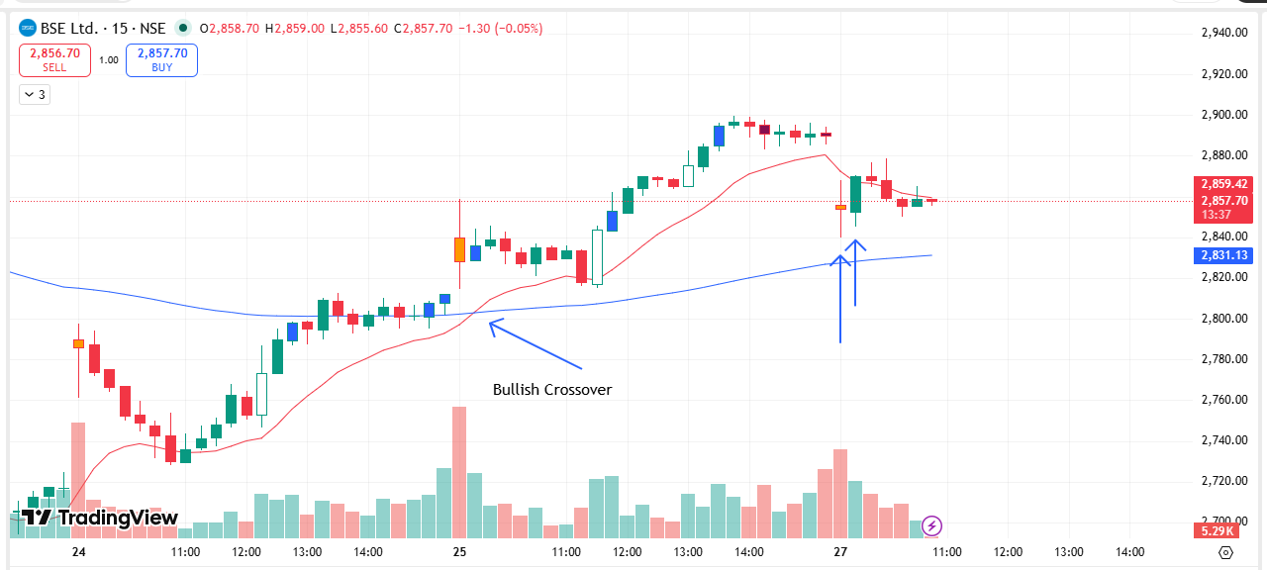
🟢 BULLISH SIGNAL --- DRREDDY

Nifty Bias : 🔴 SHORT — Counter Trend ⚠️
Crossover : 2026-03-25 10:30 (2 days ago)
Pullback : 2026-03-27 09:15
Low ₹1282.3 ≤ EMA9(Low) ₹1294.83
High ₹1297 (breakout level)
Confirm : 2026-03-27 09:30 (+1 candle)
Close ₹1297.7 > Pullback High ₹1297 (body breakout)
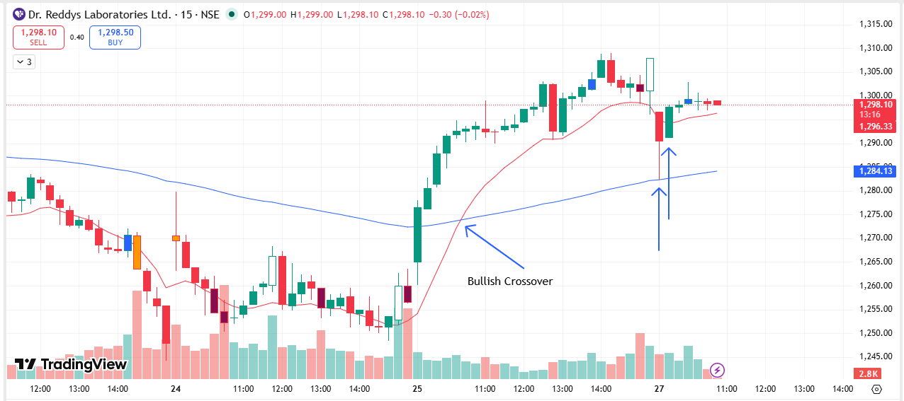
🟢 BULLISH SIGNAL --- LUPIN

Nifty Bias : 🔴 SHORT — Counter Trend ⚠️
Crossover : 2026-03-24 12:15 (3 days ago)
Pullback : 2026-03-25 15:00
Low ₹2345.5 ≤ EMA9(Low) ₹2346.9
High ₹2351 (breakout level)
Confirm : 2026-03-27 09:30 (+3 candle)
Close ₹2354 > Pullback High ₹2351 (body breakout)
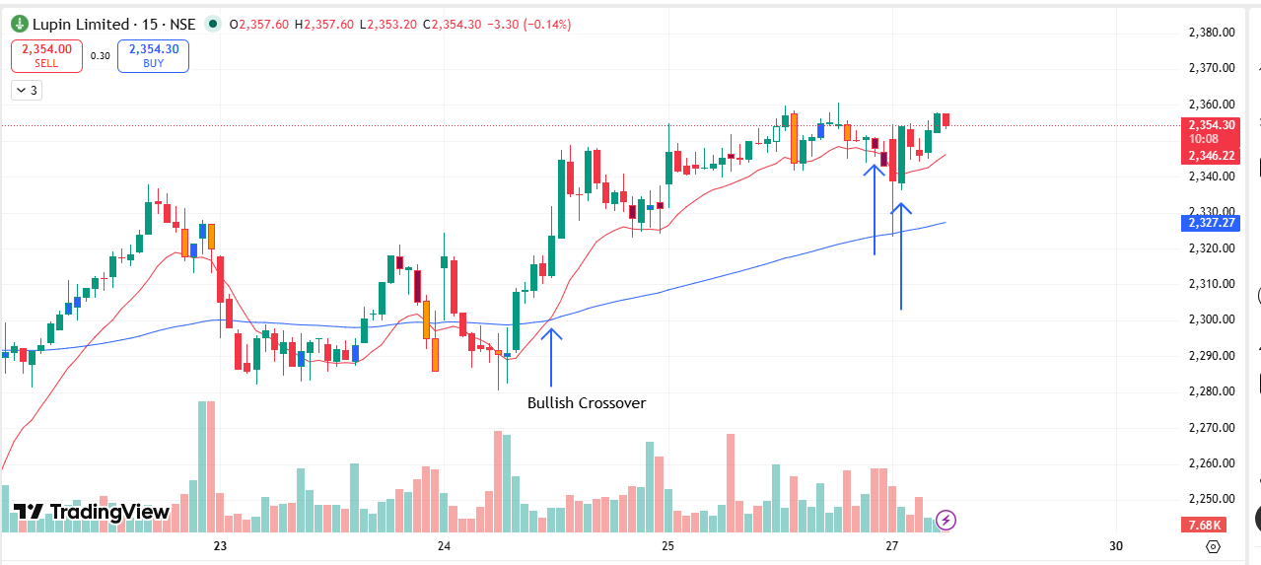
🟢 BULLISH SIGNAL --- MCX

Nifty Bias : 🔴 SHORT — Counter Trend ⚠️
Crossover : 2026-03-25 09:30 (2 days ago)
Pullback : 2026-03-25 15:15
Low ₹2456.1 ≤ EMA9(Low) ₹2463.14
High ₹2466.8 (breakout level)
Confirm : 2026-03-27 09:30 (+2 candle)
Close ₹2472.6 > Pullback High ₹2466.8 (body breakout)
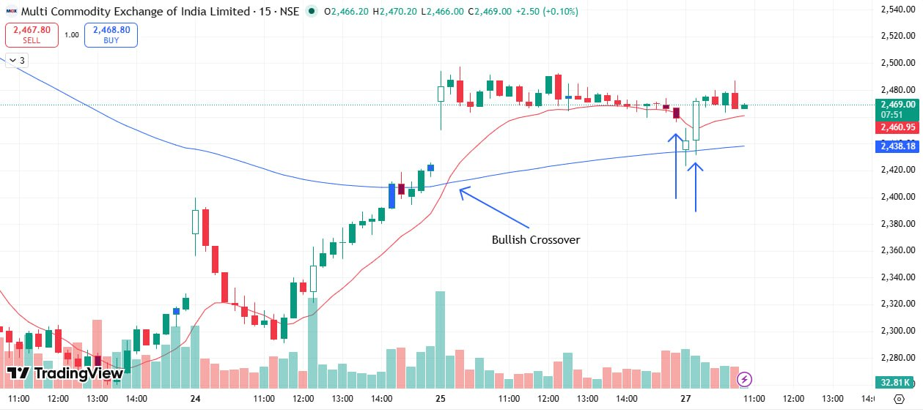

🟢 BULLISH SIGNAL --- NMDC

Nifty Bias : 🔴 SHORT — Counter Trend ⚠️
Crossover : 2026-03-25 10:00 (2 days ago)
Pullback : 2026-03-25 15:15
Low ₹77.7 ≤ EMA9(Low) ₹77.8
High ₹77.88 (breakout level)
Confirm : 2026-03-27 09:30 (+2 candle)
Close ₹78.13 > Pullback High ₹77.88 (body breakout)
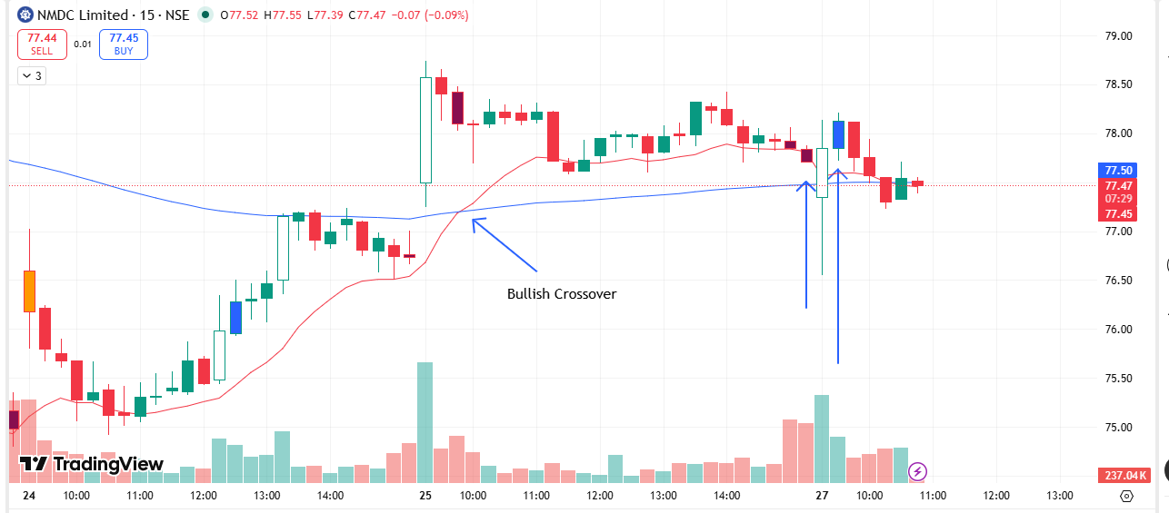
🟢 BULLISH SIGNAL --- NTPC

Nifty Bias : 🔴 SHORT — Counter Trend ⚠️
Crossover : 2026-03-25 11:15 (2 days ago)
Pullback : 2026-03-25 15:15
Low ₹377.85 ≤ EMA9(Low) ₹378.02
High ₹378.55 (breakout level)
Confirm : 2026-03-27 09:30 (+2 candle)
Close ₹378.75 > Pullback High ₹378.55 (body breakout)
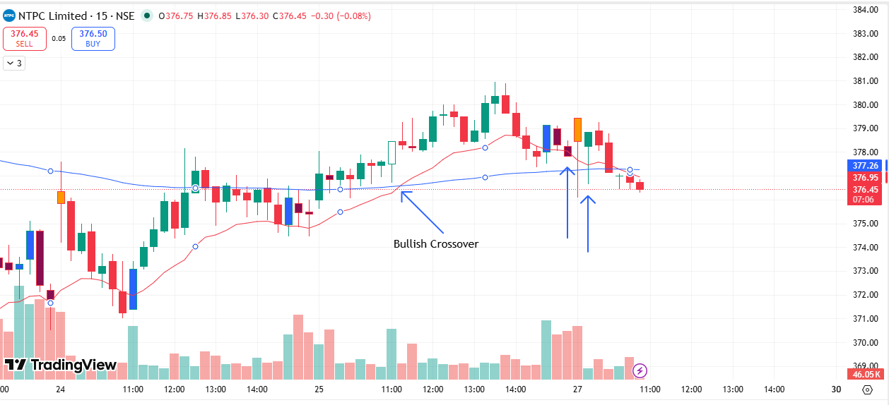
🟢 BULLISH SIGNAL --- NESTLEIND

Nifty Bias : 🔴 SHORT — Counter Trend ⚠️
Crossover : 2026-03-25 09:45 (2 days ago)
Pullback : 2026-03-25 15:00
Low ₹1202.2 ≤ EMA9(Low) ₹1206.11
High ₹1205.8 (breakout level)
Confirm : 2026-03-27 09:30 (+3 candle)
Close ₹1206.2 > Pullback High ₹1205.8 (body breakout)
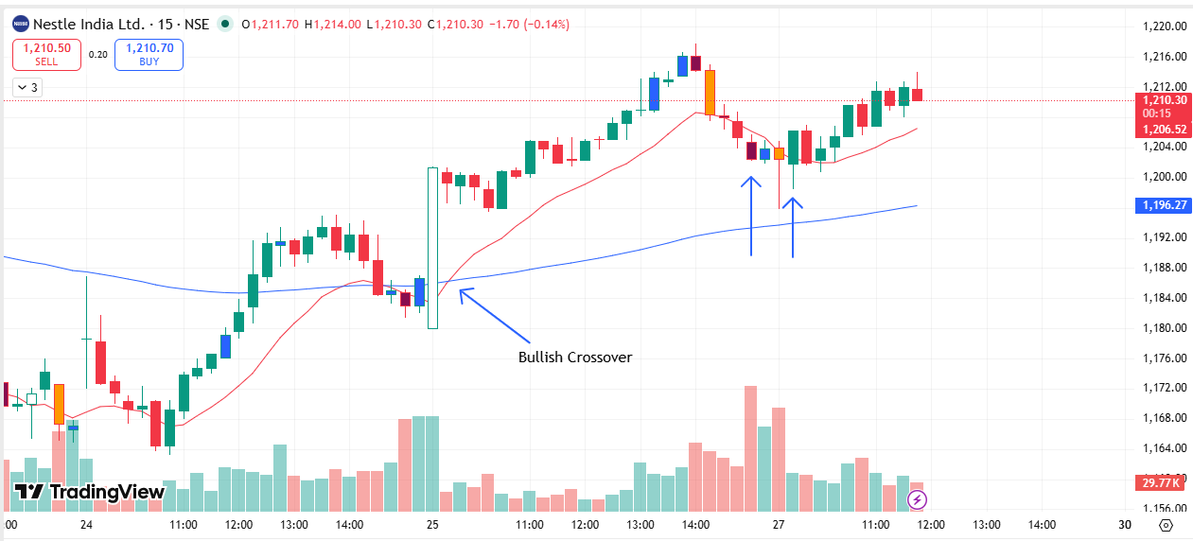
🟢 BULLISH SIGNAL --- SAMMAANCAP

Nifty Bias : 🔴 SHORT — Counter Trend ⚠️
Crossover : 2026-03-24 13:45 (3 days ago)
Pullback : 2026-03-25 15:15
Low ₹145.93 ≤ EMA9(Low) ₹146.08
High ₹147.8 (breakout level)
Confirm : 2026-03-27 09:30 (+2 candle)
Close ₹149.01 > Pullback High ₹147.8 (body breakout)
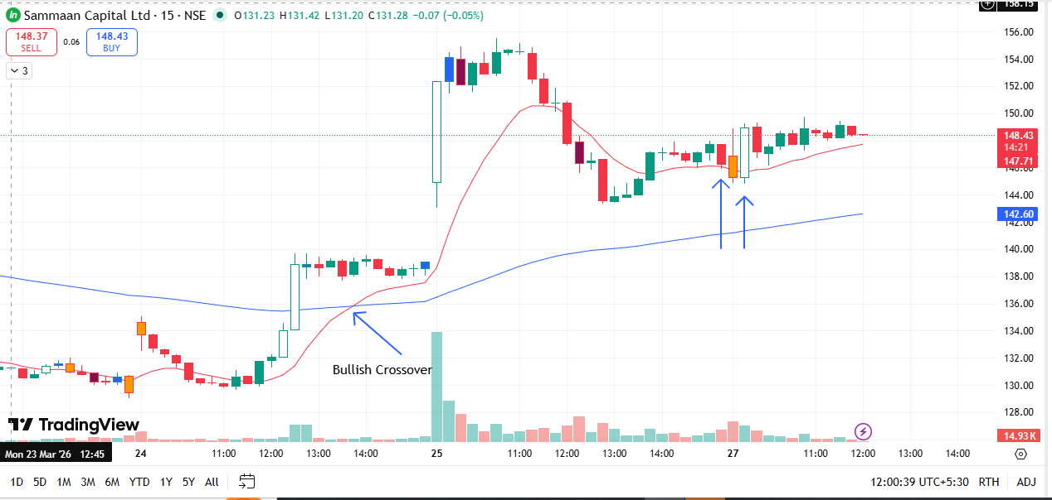
🟢 BULLISH SIGNAL --- ALKEM

Nifty Bias : 🔴 SHORT — Counter Trend ⚠️
Crossover : 2026-03-24 14:00 (3 days ago)
Pullback : 2026-03-27 09:30
Low ₹5360 ≤ EMA9(Low) ₹5403.9
High ₹5385 (breakout level)
Confirm : 2026-03-27 09:45 (+1 candle)
Close ₹5393 > Pullback High ₹5385 (body breakout)
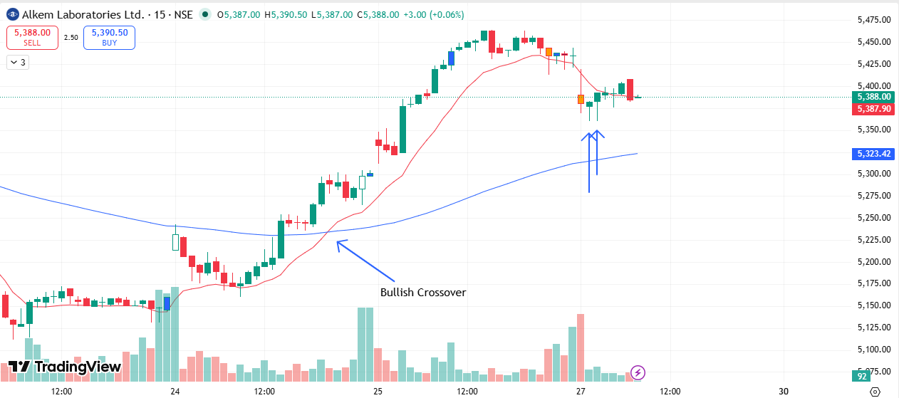
🟢 BULLISH SIGNAL --- BHARTIARTL

Nifty Bias : 🔴 SHORT — Counter Trend ⚠️
Crossover : 2026-03-25 11:45 (2 days ago)
Pullback : 2026-03-25 15:15
Low ₹1830.3 ≤ EMA9(Low) ₹1833.76
High ₹1836.6 (breakout level)
Confirm : 2026-03-27 09:45 (+3 candle)
Close ₹1840 > Pullback High ₹1836.6 (body breakout)
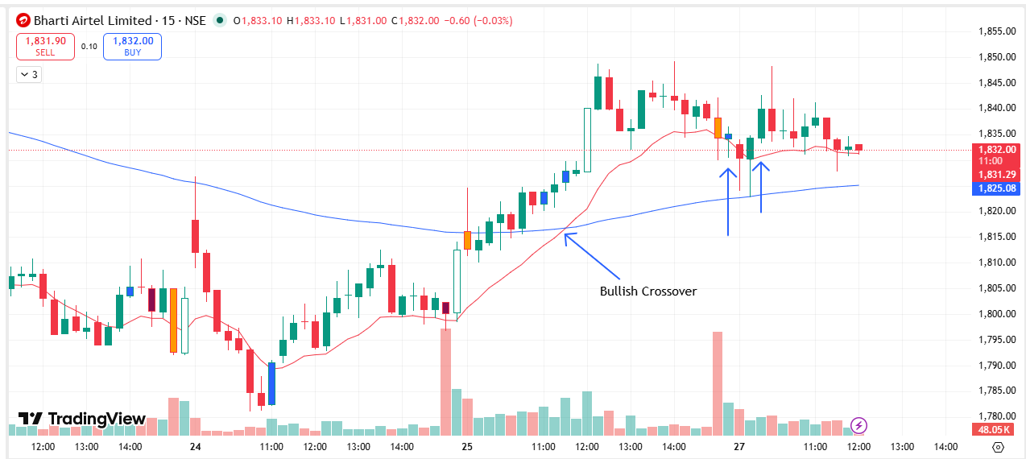
🔴 BEARISH SIGNAL --- BDL

Nifty Bias : 🔴 SHORT — Aligned ✅
Crossover : 2026-03-19 10:00 (8 days ago)
Pullback : 2026-03-27 09:15
High ₹1204 ≥ EMA9(High) ₹1188.62
Low ₹1180.8 (breakdown level)
Confirm : 2026-03-27 09:45 (+2 candle)
Close ₹1173.4 < Pullback Low ₹1180.8 (body breakdown)
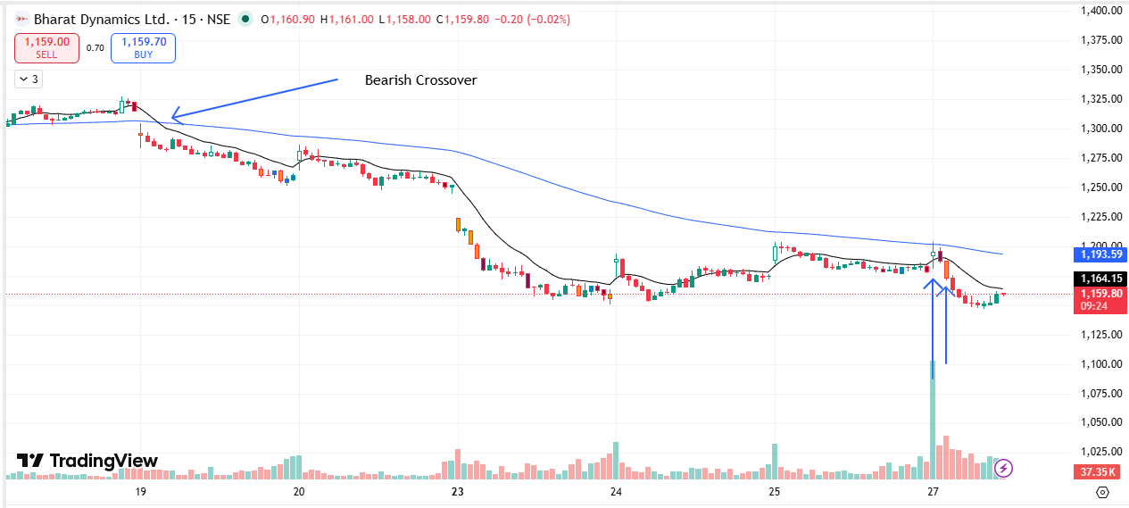
🔴 BEARISH SIGNAL --- COALINDIA

Nifty Bias : 🔴 SHORT — Aligned ✅
Crossover : 2026-03-23 10:45 (4 days ago)
Pullback : 2026-03-27 09:15
High ₹447.5 ≥ EMA9(High) ₹445.35
Low ₹443.5 (breakdown level)
Confirm : 2026-03-27 09:30 (+1 candle)
Close ₹442.9 < Pullback Low ₹443.5 (body breakdown)
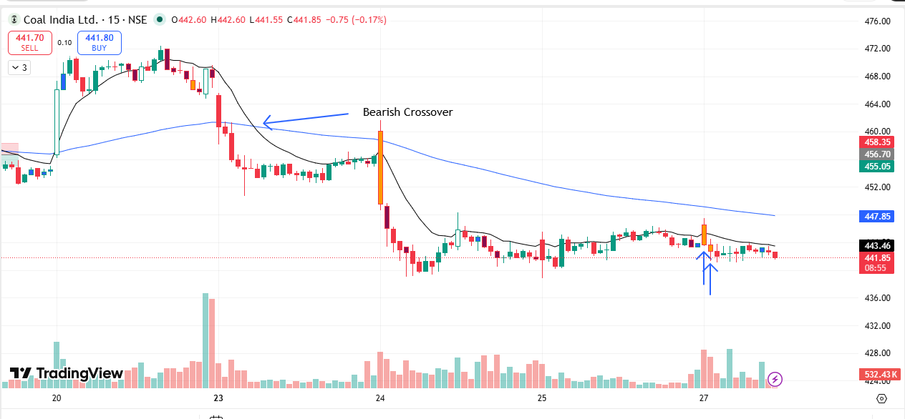
🟢 BULLISH SIGNAL --- FORTIS

Nifty Bias : 🔴 SHORT — Counter Trend ⚠️
Crossover : 2026-03-25 09:30 (2 days ago)
Pullback : 2026-03-27 09:30
Low ₹820 ≤ EMA9(Low) ₹824.4
High ₹826 (breakout level)
Confirm : 2026-03-27 09:45 (+1 candle)
Close ₹827.2 > Pullback High ₹826 (body breakout)
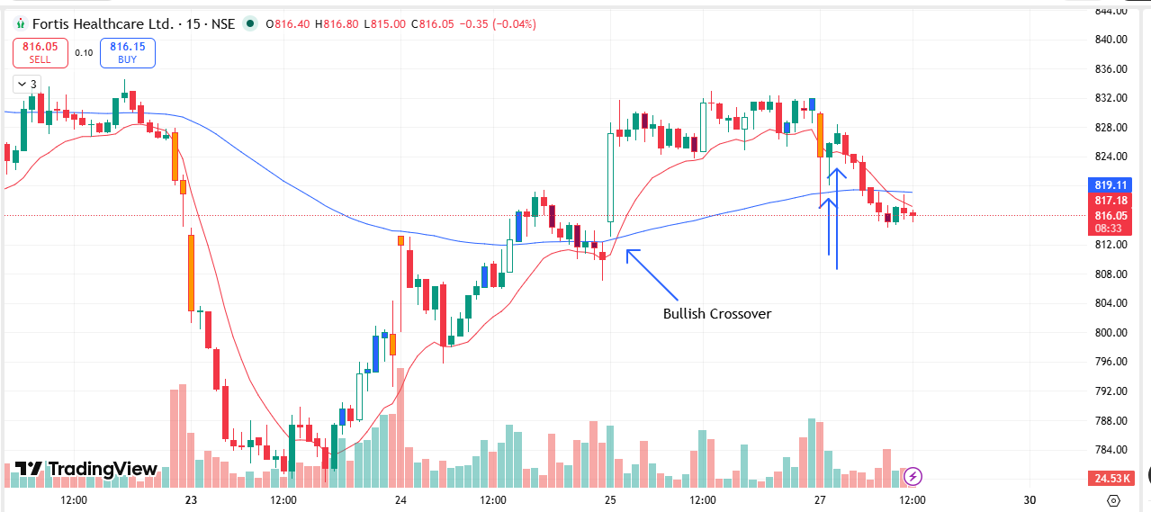
🔴 BEARISH SIGNAL --- GAIL

Nifty Bias : 🔴 SHORT — Aligned ✅
Crossover : 2026-03-19 10:45 (8 days ago)
Pullback : 2026-03-25 15:00
High ₹139.6 ≥ EMA9(High) ₹139.32
Low ₹138.82 (breakdown level)
Confirm : 2026-03-27 09:30 (+3 candle)
Close ₹138.5 < Pullback Low ₹138.82 (body breakdown)
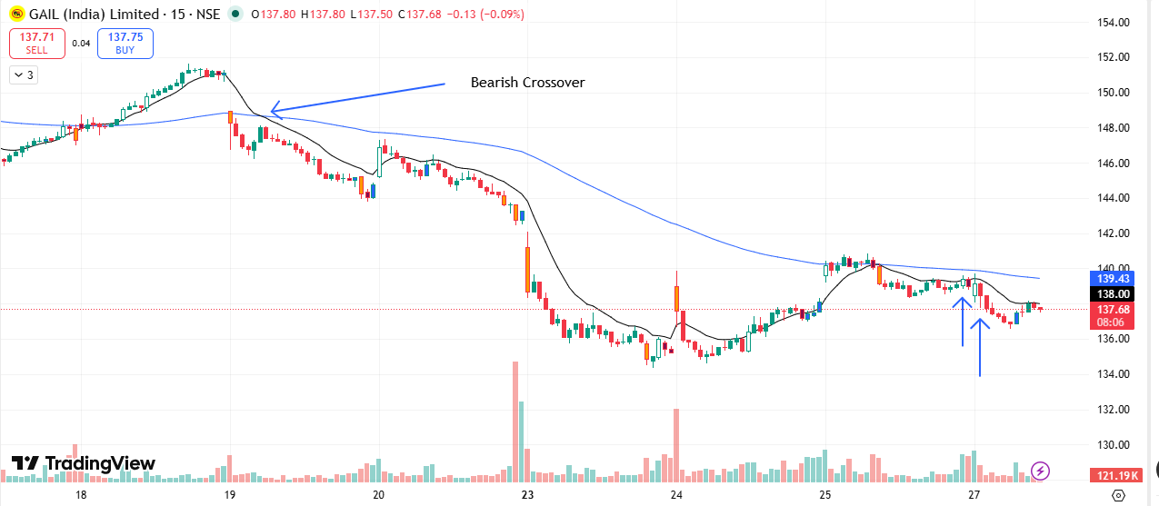
🟢 BULLISH SIGNAL --- HCLTECH

Nifty Bias : 🔴 SHORT — Counter Trend ⚠️
Crossover : 2026-03-23 11:00 (4 days ago)
Pullback : 2026-03-25 14:45
Low ₹1383.6 ≤ EMA9(Low) ₹1391.11
High ₹1392.4 (breakout level)
Confirm : 2026-03-27 09:15 (+3 candle)
Close ₹1400.5 > Pullback High ₹1392.4 (body breakout)
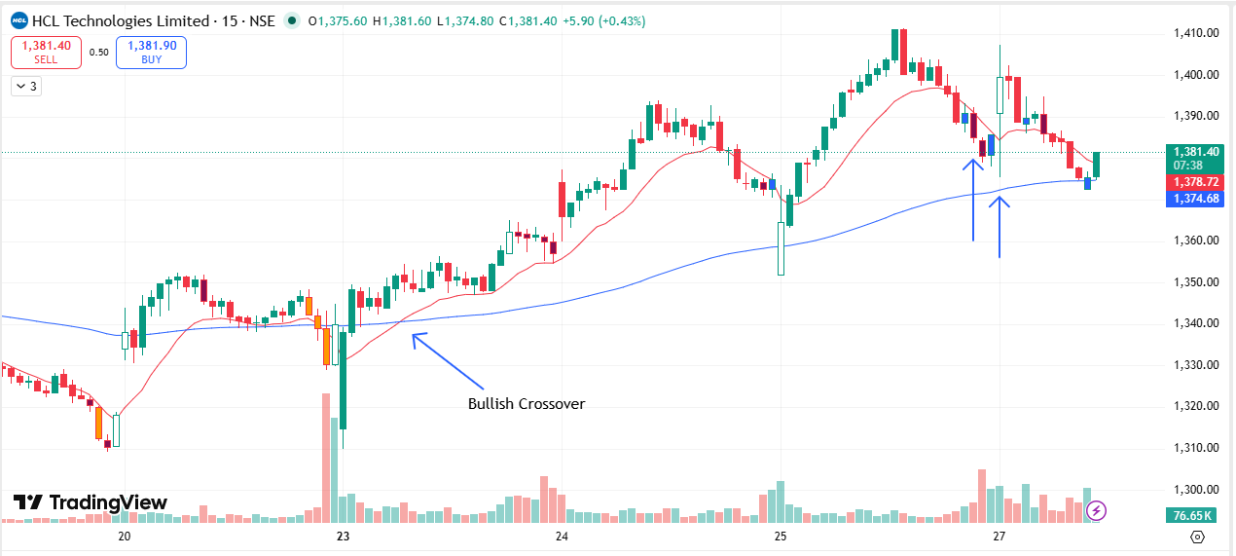
🟢 BULLISH SIGNAL --- INFY

Nifty Bias : 🔴 SHORT — Counter Trend ⚠️
Crossover : 2026-03-23 14:15 (4 days ago)
Pullback : 2026-03-25 14:45
Low ₹1277 ≤ EMA9(Low) ₹1280.57
High ₹1281.7 (breakout level)
Confirm : 2026-03-27 09:15 (+3 candle)
Close ₹1287 > Pullback High ₹1281.7 (body breakout)
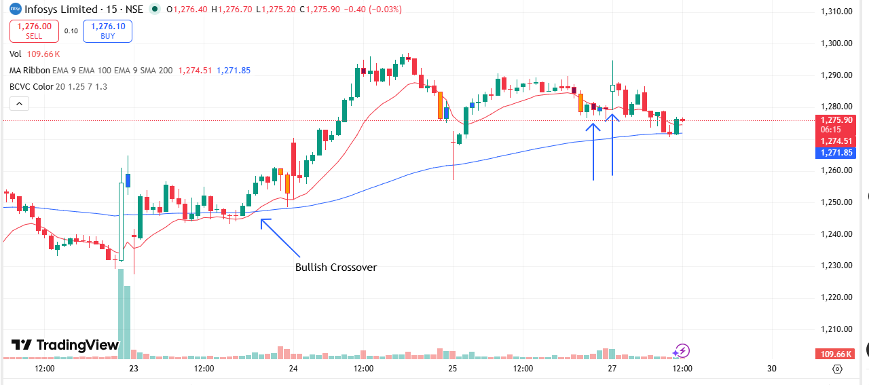
🟢 BULLISH SIGNAL --- MUTHOOTFIN

Nifty Bias : 🔴 SHORT — Counter Trend ⚠️
Crossover : 2026-03-25 10:00 (2 days ago)
Pullback : 2026-03-27 09:30
Low ₹3250 ≤ EMA9(Low) ₹3277.65
High ₹3276.9 (breakout level)
Confirm : 2026-03-27 09:45 (+1 candle)
Close ₹3286.8 > Pullback High ₹3276.9 (body breakout)
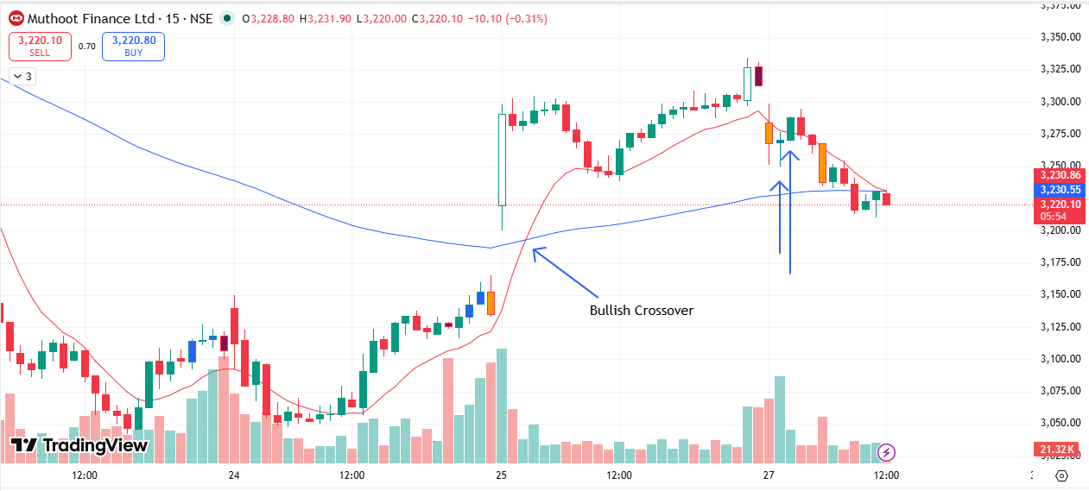
🟢 BULLISH SIGNAL --- PERSISTENT

Nifty Bias : 🔴 SHORT — Counter Trend ⚠️
Crossover : 2026-03-20 10:00 (7 days ago)
Pullback : 2026-03-27 09:15
Low ₹4851.1 ≤ EMA9(Low) ₹4902.44
High ₹4972.5 (breakout level)
Confirm : 2026-03-27 09:30 (+1 candle)
Close ₹4980 > Pullback High ₹4972.5 (body breakout)
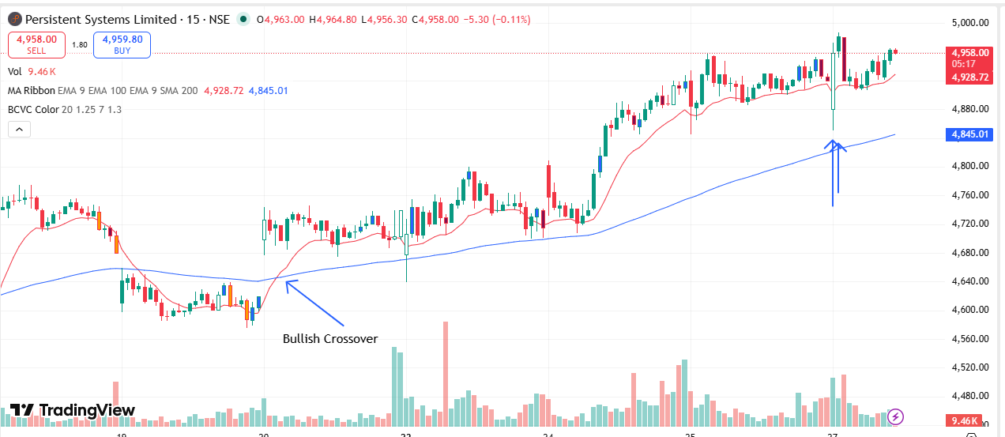
🟢 BULLISH SIGNAL --- PPLPHARMA

Nifty Bias : 🔴 SHORT — Counter Trend ⚠️
Crossover : 2026-03-25 09:45 (2 days ago)
Pullback : 2026-03-27 09:15
Low ₹138.87 ≤ EMA9(Low) ₹141.15
High ₹140.61 (breakout level)
Confirm : 2026-03-27 09:45 (+2 candle)
Close ₹141.12 > Pullback High ₹140.61 (body breakout)
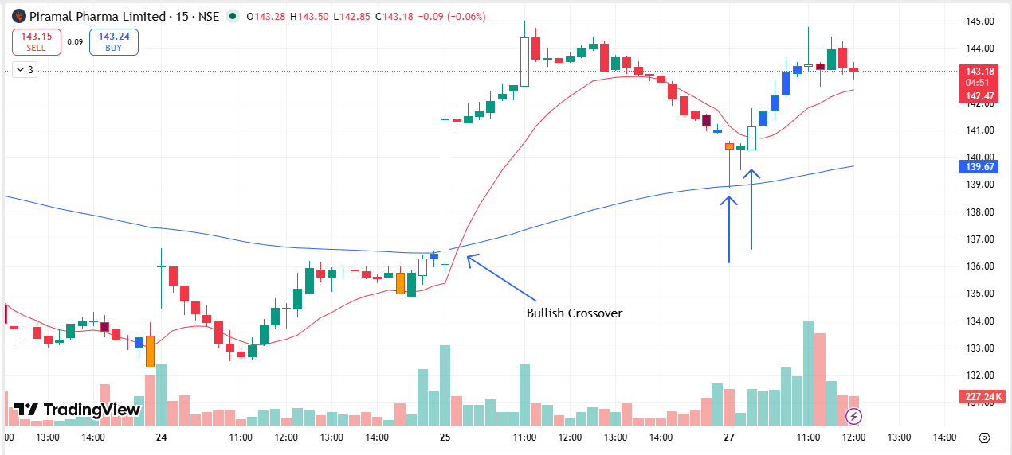
🔴 BEARISH SIGNAL --- SBILIFE

Nifty Bias : 🔴 SHORT — Aligned ✅
Crossover : 2026-03-19 12:00 (8 days ago)
Pullback : 2026-03-25 15:15
High ₹1859.8 ≥ EMA9(High) ₹1858.67
Low ₹1846.4 (breakdown level)
Confirm : 2026-03-27 09:15 (+1 candle)
Close ₹1842.4 < Pullback Low ₹1846.4 (body breakdown)
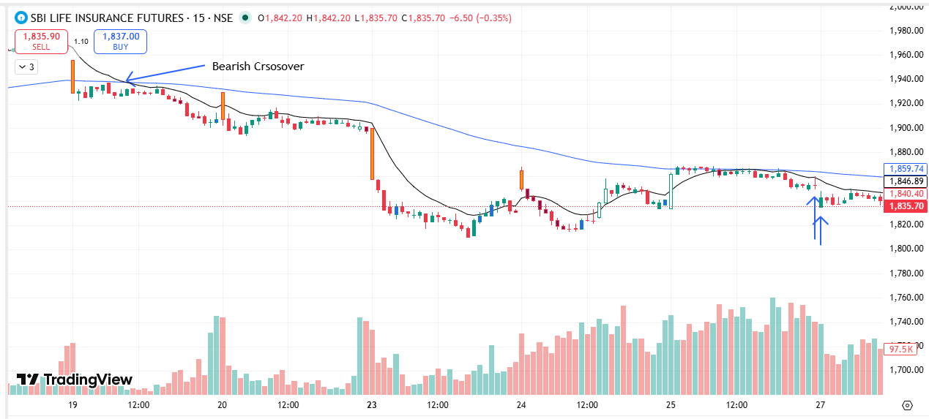
🟢 BULLISH SIGNAL --- TECHM

Nifty Bias : 🔴 SHORT — Counter Trend ⚠️
Crossover : 2026-03-20 10:00 (7 days ago)
Pullback : 2026-03-25 15:00
Low ₹1409.1 ≤ EMA9(Low) ₹1414.73
High ₹1413.9 (breakout level)
Confirm : 2026-03-27 09:15 (+2 candle)
Close ₹1414 > Pullback High ₹1413.9 (body breakout)
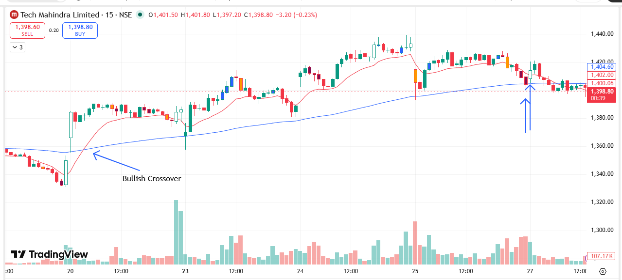
🟢 BULLISH SIGNAL --- TORNTPHARM

Nifty Bias : 🔴 SHORT — Counter Trend ⚠️
Crossover : 2026-03-25 09:30 (2 days ago)
Pullback : 2026-03-27 09:30
Low ₹4265 ≤ EMA9(Low) ₹4284.56
High ₹4282.1 (breakout level)
Confirm : 2026-03-27 09:45 (+1 candle)
Close ₹4289.1 > Pullback High ₹4282.1 (body breakout)
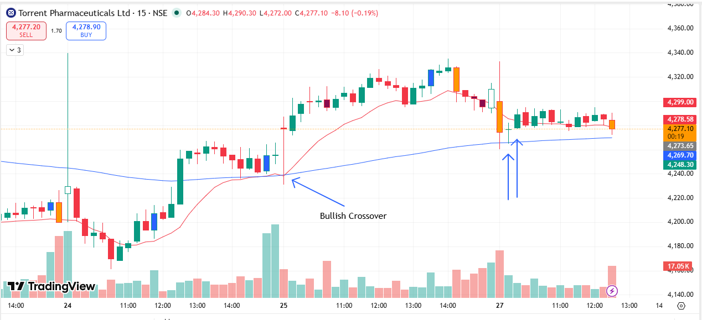
🟢 BULLISH SIGNAL --- AXISBANK

Nifty Bias : 🔴 SHORT — Counter Trend ⚠️
Crossover : 2026-03-25 09:45 (2 days ago)
Pullback : 2026-03-27 09:30
Low ₹1203.2 ≤ EMA9(Low) ₹1216.88
High ₹1206.3 (breakout level)
Confirm : 2026-03-27 10:00 (+2 candle)
Close ₹1206.4 > Pullback High ₹1206.3 (body breakout)
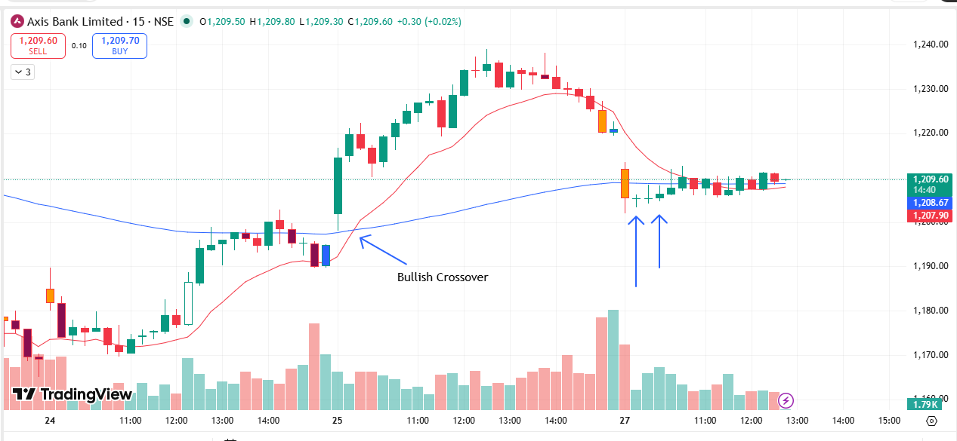
🟢 BULLISH SIGNAL --- GRASIM

Nifty Bias : 🔴 SHORT — Counter Trend ⚠️
Crossover : 2026-03-25 10:15 (2 days ago)
Pullback : 2026-03-27 09:45
Low ₹2610 ≤ EMA9(Low) ₹2627.35
High ₹2620.6 (breakout level)
Confirm : 2026-03-27 10:00 (+1 candle)
Close ₹2623.1 > Pullback High ₹2620.6 (body breakout)
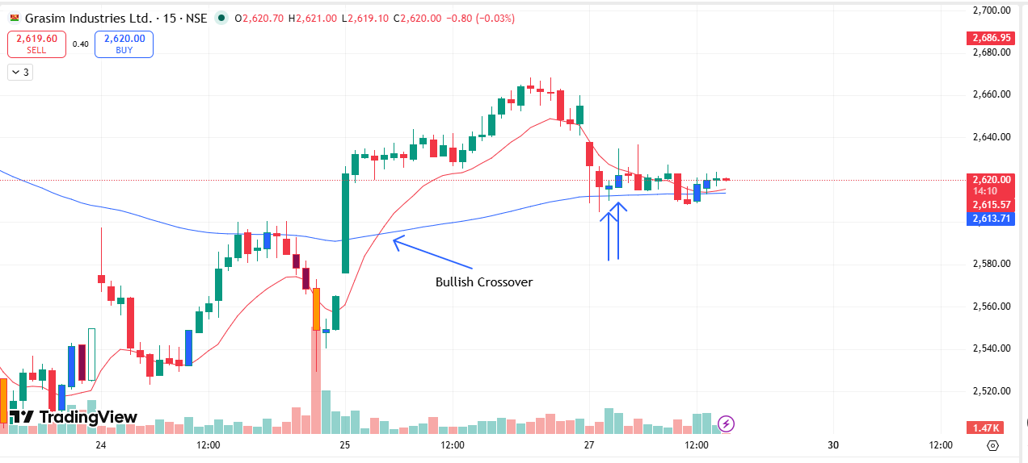
🟢 BULLISH SIGNAL --- HINDZINC

Nifty Bias : 🔴 SHORT — Counter Trend ⚠️
Crossover : 2026-03-25 10:15 (2 days ago)
Pullback : 2026-03-27 09:30
Low ₹511.85 ≤ EMA9(Low) ₹513.96
High ₹515.25 (breakout level)
Confirm : 2026-03-27 10:00 (+2 candle)
Close ₹516.3 > Pullback High ₹515.25 (body breakout)
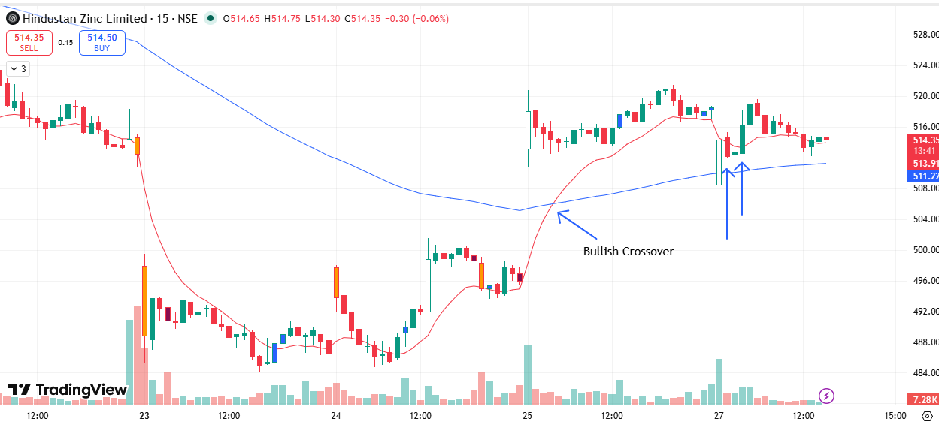
🟢 BULLISH SIGNAL --- POWERINDIA

Nifty Bias : 🔴 SHORT — Counter Trend ⚠️
Crossover : 2026-03-24 11:45 (3 days ago)
Pullback : 2026-03-27 09:30
Low ₹25125 ≤ EMA9(Low) ₹25443.26
High ₹25275 (breakout level)
Confirm : 2026-03-27 10:00 (+2 candle)
Close ₹25350 > Pullback High ₹25275 (body breakout)
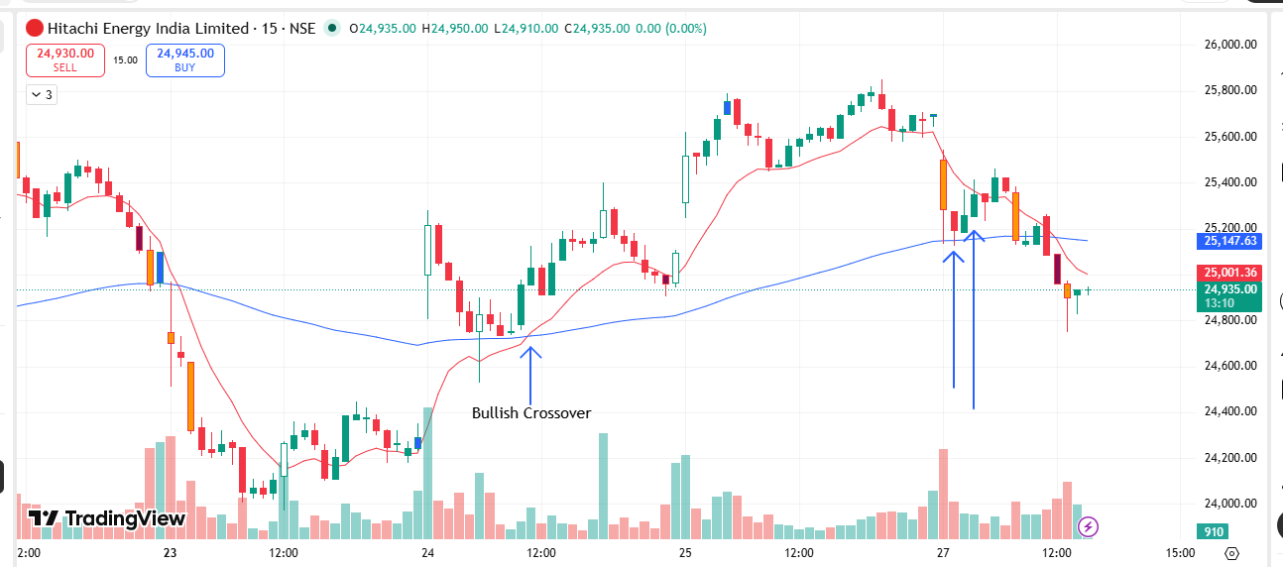
🟢 BULLISH SIGNAL --- M&M

Nifty Bias : 🔴 SHORT — Counter Trend ⚠️
Crossover : 2026-03-25 09:15 (2 days ago)
Pullback : 2026-03-27 10:00
Low ₹3046.6 ≤ EMA9(Low) ₹3085.22
High ₹3067.8 (breakout level)
Confirm : 2026-03-27 10:15 (+1 candle)
Close ₹3076.9 > Pullback High ₹3067.8 (body breakout)
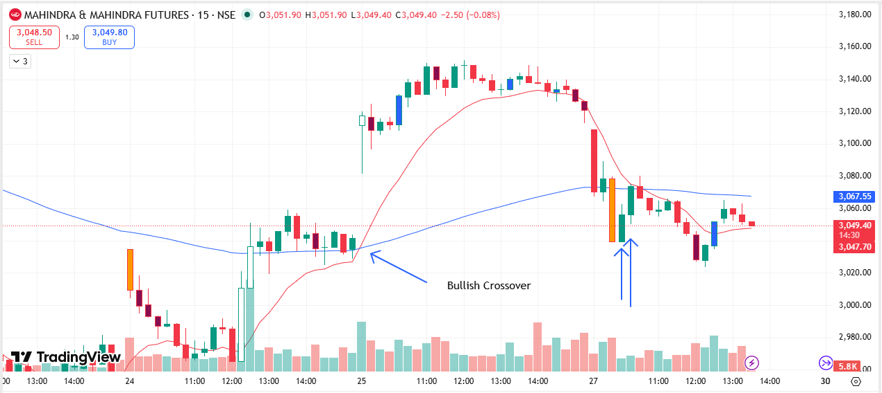
🟢 BULLISH SIGNAL --- RVNL

Nifty Bias : 🔴 SHORT — Counter Trend ⚠️
Crossover : 2026-03-25 09:45 (2 days ago)
Pullback : 2026-03-27 10:00
Low ₹263.65 ≤ EMA9(Low) ₹266.35
High ₹265.2 (breakout level)
Confirm : 2026-03-27 10:15 (+1 candle)
Close ₹265.45 > Pullback High ₹265.2 (body breakout)
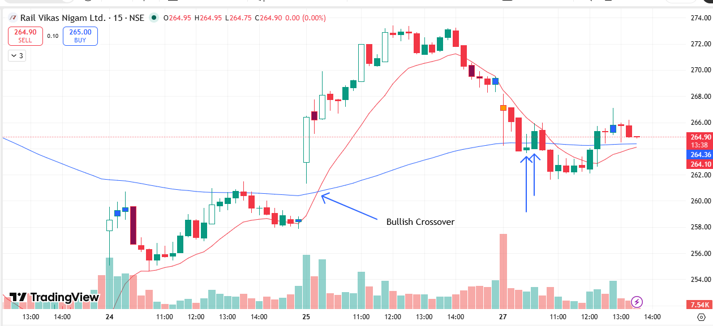
🟢 BULLISH SIGNAL --- SHREECEM

Nifty Bias : 🔴 SHORT — Counter Trend ⚠️
Crossover : 2026-03-24 14:15 (3 days ago)
Pullback : 2026-03-27 09:45
Low ₹23625 ≤ EMA9(Low) ₹23895.4
High ₹23730 (breakout level)
Confirm : 2026-03-27 10:15 (+2 candle)
Close ₹23805 > Pullback High ₹23730 (body breakout)
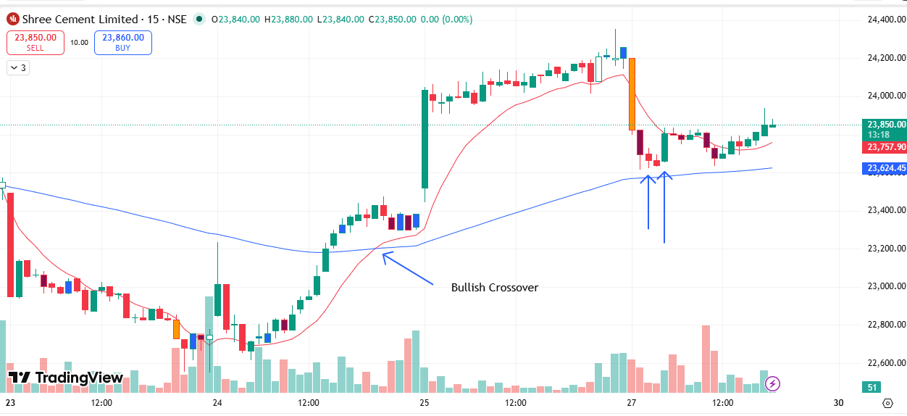
🟢 BULLISH SIGNAL --- SRF

Nifty Bias : 🔴 SHORT — Counter Trend ⚠️
Crossover : 2026-03-24 14:30 (3 days ago)
Pullback : 2026-03-27 10:00
Low ₹2524.7 ≤ EMA9(Low) ₹2540.12
High ₹2535.4 (breakout level)
Confirm : 2026-03-27 10:15 (+1 candle)
Close ₹2537 > Pullback High ₹2535.4 (body breakout)
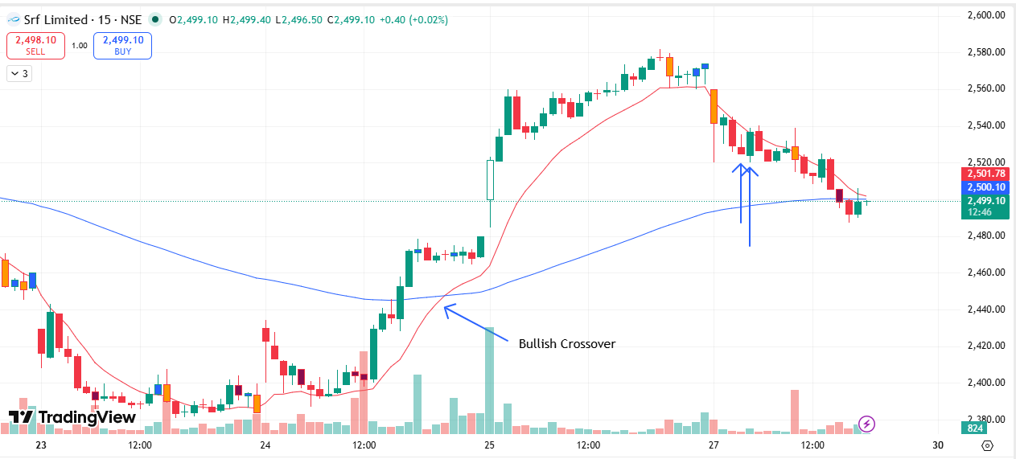
🟢 BULLISH SIGNAL --- ULTRACEMCO

Nifty Bias : 🔴 SHORT — Counter Trend ⚠️
Crossover : 2026-03-25 09:15 (2 days ago)
Pullback : 2026-03-27 10:00
Low ₹11019 ≤ EMA9(Low) ₹11065.31
High ₹11055 (breakout level)
Confirm : 2026-03-27 10:15 (+1 candle)
Close ₹11057 > Pullback High ₹11055 (body breakout)
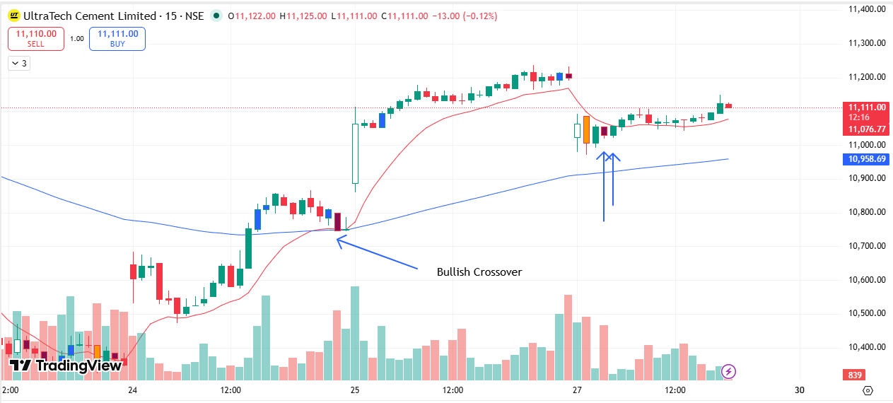
🟢 BULLISH SIGNAL --- APLAPOLLO

Nifty Bias : 🔴 SHORT — Counter Trend ⚠️
Crossover : 2026-03-24 13:45 (3 days ago)
Pullback : 2026-03-27 10:00
Low ₹1976 ≤ EMA9(Low) ₹1983.69
High ₹1984.8 (breakout level)
Confirm : 2026-03-27 10:30 (+2 candle)
Close ₹1992.8 > Pullback High ₹1984.8 (body breakout)
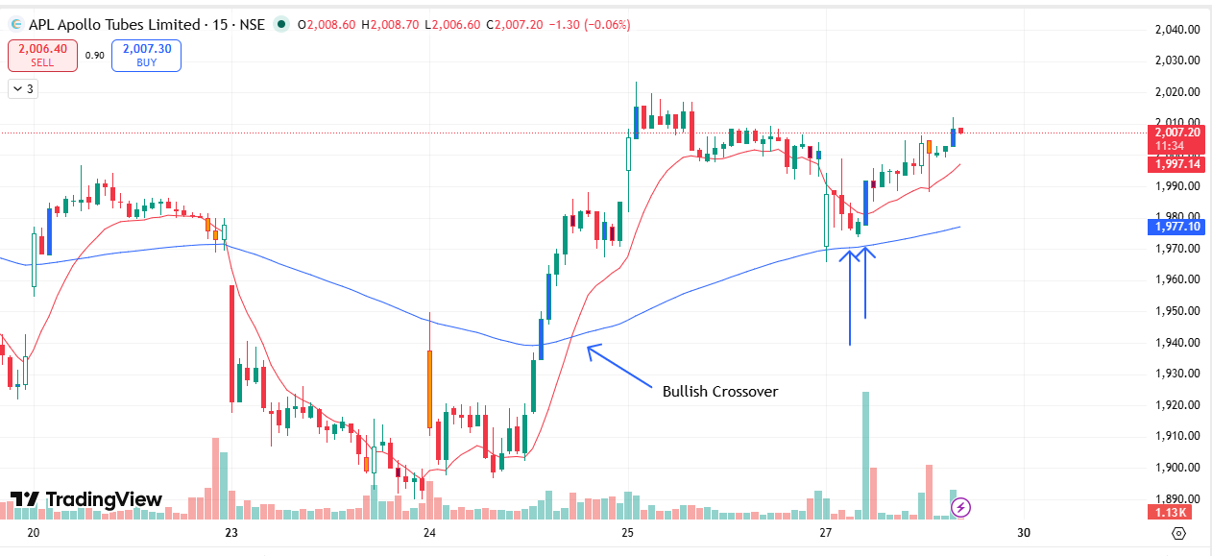
🟢 BULLISH SIGNAL --- AUBANK

Nifty Bias : 🔴 SHORT — Counter Trend ⚠️
Crossover : 2026-03-25 09:45 (2 days ago)
Pullback : 2026-03-27 10:15
Low ₹886.6 ≤ EMA9(Low) ₹895.79
High ₹890.1 (breakout level)
Confirm : 2026-03-27 10:30 (+1 candle)
Close ₹891.35 > Pullback High ₹890.1 (body breakout)

🟢 BULLISH SIGNAL --- APOLLOHOSP

Nifty Bias : 🔴 SHORT — Counter Trend ⚠️
Crossover : 2026-03-24 11:30 (3 days ago)
Pullback : 2026-03-27 09:45
Low ₹7528.5 ≤ EMA9(Low) ₹7549.78
High ₹7549 (breakout level)
Confirm : 2026-03-27 10:30 (+3 candle)
Close ₹7578 > Pullback High ₹7549 (body breakout)

🟢 BULLISH SIGNAL --- BAJFINANCE

Nifty Bias : 🔴 SHORT — Counter Trend ⚠️
Crossover : 2026-03-24 13:15 (3 days ago)
Pullback : 2026-03-27 10:15
Low ₹852.45 ≤ EMA9(Low) ₹862.78
High ₹857.8 (breakout level)
Confirm : 2026-03-27 10:30 (+1 candle)
Close ₹858.35 > Pullback High ₹857.8 (body breakout)

🟢 BULLISH SIGNAL --- COFORGE

Nifty Bias : 🔴 SHORT — Counter Trend ⚠️
Crossover : 2026-03-24 12:15 (3 days ago)
Pullback : 2026-03-27 10:15
Low ₹1154.7 ≤ EMA9(Low) ₹1157.42
High ₹1160.8 (breakout level)
Confirm : 2026-03-27 10:30 (+1 candle)
Close ₹1163.7 > Pullback High ₹1160.8 (body breakout)

🟢 BULLISH SIGNAL --- ETERNAL

Nifty Bias : 🔴 SHORT — Counter Trend ⚠️
Crossover : 2026-03-24 10:45 (3 days ago)
Pullback : 2026-03-27 10:15
Low ₹235 ≤ EMA9(Low) ₹237.4
High ₹236.42 (breakout level)
Confirm : 2026-03-27 10:30 (+1 candle)
Close ₹236.61 > Pullback High ₹236.42 (body breakout)

🟢 BULLISH SIGNAL --- HINDPETRO

Nifty Bias : 🔴 SHORT — Counter Trend ⚠️
Crossover : 2026-03-24 14:15 (3 days ago)
Pullback : 2026-03-27 10:15
Low ₹339.3 ≤ EMA9(Low) ₹340.95
High ₹341.7 (breakout level)
Confirm : 2026-03-27 10:30 (+1 candle)
Close ₹342.1 > Pullback High ₹341.7 (body breakout)

🟢 BULLISH SIGNAL --- KALYANKJIL

Nifty Bias : 🔴 SHORT — Counter Trend ⚠️
Crossover : 2026-03-25 09:45 (2 days ago)
Pullback : 2026-03-27 10:15
Low ₹383.1 ≤ EMA9(Low) ₹387.42
High ₹385.9 (breakout level)
Confirm : 2026-03-27 10:30 (+1 candle)
Close ₹386.4 > Pullback High ₹385.9 (body breakout)

🟢 BULLISH SIGNAL --- LT

Nifty Bias : 🔴 SHORT — Counter Trend ⚠️
Crossover : 2026-03-24 13:00 (3 days ago)
Pullback : 2026-03-27 09:45
Low ₹3547 ≤ EMA9(Low) ₹3595.17
High ₹3566 (breakout level)
Confirm : 2026-03-27 10:30 (+3 candle)
Close ₹3567.8 > Pullback High ₹3566 (body breakout)

🟢 BULLISH SIGNAL --- MANKIND

Nifty Bias : 🔴 SHORT — Counter Trend ⚠️
Crossover : 2026-03-25 10:00 (2 days ago)
Pullback : 2026-03-27 10:15
Low ₹2021.1 ≤ EMA9(Low) ₹2021.96
High ₹2028.5 (breakout level)
Confirm : 2026-03-27 10:30 (+1 candle)
Close ₹2033.7 > Pullback High ₹2028.5 (body breakout)

🟢 BULLISH SIGNAL --- MAXHEALTH

Nifty Bias : 🔴 SHORT — Counter Trend ⚠️
Crossover : 2026-03-24 10:45 (3 days ago)
Pullback : 2026-03-27 10:15
Low ₹974.3 ≤ EMA9(Low) ₹977.72
High ₹978.3 (breakout level)
Confirm : 2026-03-27 10:30 (+1 candle)
Close ₹980.9 > Pullback High ₹978.3 (body breakout)

🟢 BULLISH SIGNAL --- OBEROIRLTY

Nifty Bias : 🔴 SHORT — Counter Trend ⚠️
Crossover : 2026-03-24 13:00 (3 days ago)
Pullback : 2026-03-27 10:15
Low ₹1471 ≤ EMA9(Low) ₹1478.21
High ₹1478.2 (breakout level)
Confirm : 2026-03-27 10:30 (+1 candle)
Close ₹1482 > Pullback High ₹1478.2 (body breakout)

🟢 BULLISH SIGNAL --- TATASTEEL

Nifty Bias : 🔴 SHORT — Counter Trend ⚠️
Crossover : 2026-03-25 09:30 (2 days ago)
Pullback : 2026-03-27 10:15
Low ₹193.78 ≤ EMA9(Low) ₹194.63
High ₹194.55 (breakout level)
Confirm : 2026-03-27 10:30 (+1 candle)
Close ₹194.96 > Pullback High ₹194.55 (body breakout)

🟢 BULLISH SIGNAL --- GLENMARK

Nifty Bias : 🔴 SHORT — Counter Trend ⚠️
Crossover : 2026-03-25 11:00 (2 days ago)
Pullback : 2026-03-27 10:15
Low ₹2146.6 ≤ EMA9(Low) ₹2154.32
High ₹2158.4 (breakout level)
Confirm : 2026-03-27 10:45 (+2 candle)
Close ₹2159.4 > Pullback High ₹2158.4 (body breakout)

🟢 BULLISH SIGNAL --- PNBHOUSING

Nifty Bias : 🔴 SHORT — Counter Trend ⚠️
Crossover : 2026-03-24 13:30 (3 days ago)
Pullback : 2026-03-27 10:00
Low ₹788.1 ≤ EMA9(Low) ₹794.36
High ₹792.35 (breakout level)
Confirm : 2026-03-27 10:45 (+3 candle)
Close ₹794.3 > Pullback High ₹792.35 (body breakout)

🟢 BULLISH SIGNAL --- FEDERALBNK

Nifty Bias : 🔴 SHORT — Counter Trend ⚠️
Crossover : 2026-03-25 09:30 (2 days ago)
Pullback : 2026-03-27 10:15
Low ₹265.4 ≤ EMA9(Low) ₹267.63
High ₹266.25 (breakout level)
Confirm : 2026-03-27 10:45 (+2 candle)
Close ₹266.6 > Pullback High ₹266.25 (body breakout)

🟢 BULLISH SIGNAL --- DALBHARAT

Nifty Bias : 🔴 SHORT — Counter Trend ⚠️
Crossover : 2026-03-25 09:45 (2 days ago)
Pullback : 2026-03-27 10:45
Low ₹1830.1 ≤ EMA9(Low) ₹1841.1
High ₹1833.7 (breakout level)
Confirm : 2026-03-27 11:00 (+1 candle)
Close ₹1835.8 > Pullback High ₹1833.7 (body breakout)

🟢 BULLISH SIGNAL --- LTM

Nifty Bias : 🔴 SHORT — Counter Trend ⚠️
Crossover : 2026-03-24 13:00 (3 days ago)
Pullback : 2026-03-27 10:45
Low ₹4245.7 ≤ EMA9(Low) ₹4259.91
High ₹4262.7 (breakout level)
Confirm : 2026-03-27 11:00 (+1 candle)
Close ₹4265.7 > Pullback High ₹4262.7 (body breakout)

🟢 BULLISH SIGNAL --- MARICO

Nifty Bias : 🔴 SHORT — Counter Trend ⚠️
Crossover : 2026-03-25 09:15 (2 days ago)
Pullback : 2026-03-27 10:15
Low ₹745.3 ≤ EMA9(Low) ₹747.53
High ₹747.65 (breakout level)
Confirm : 2026-03-27 11:00 (+3 candle)
Close ₹750.3 > Pullback High ₹747.65 (body breakout)

🟢 BULLISH SIGNAL --- MPHASIS

Nifty Bias : 🔴 SHORT — Counter Trend ⚠️
Crossover : 2026-03-24 12:00 (3 days ago)
Pullback : 2026-03-27 10:45
Low ₹2107.3 ≤ EMA9(Low) ₹2115.79
High ₹2113.4 (breakout level)
Confirm : 2026-03-27 11:00 (+1 candle)
Close ₹2114 > Pullback High ₹2113.4 (body breakout)

🟢 BULLISH SIGNAL --- VOLTAS

Nifty Bias : 🔴 SHORT — Counter Trend ⚠️
Crossover : 2026-03-25 09:45 (2 days ago)
Pullback : 2026-03-27 10:15
Low ₹1324.1 ≤ EMA9(Low) ₹1339.03
High ₹1331.6 (breakout level)
Confirm : 2026-03-27 11:00 (+3 candle)
Close ₹1332.2 > Pullback High ₹1331.6 (body breakout)

🟢 BULLISH SIGNAL --- DELHIVERY

Nifty Bias : 🔴 SHORT — Counter Trend ⚠️
Crossover : 2026-03-24 12:45 (3 days ago)
Pullback : 2026-03-27 10:30
Low ₹421.8 ≤ EMA9(Low) ₹424.35
High ₹423.35 (breakout level)
Confirm : 2026-03-27 11:15 (+3 candle)
Close ₹423.75 > Pullback High ₹423.35 (body breakout)

🟢 BULLISH SIGNAL --- KAYNES

Nifty Bias : 🔴 SHORT — Counter Trend ⚠️
Crossover : 2026-03-25 09:30 (2 days ago)
Pullback : 2026-03-27 10:45
Low ₹3611 ≤ EMA9(Low) ₹3642.64
High ₹3628 (breakout level)
Confirm : 2026-03-27 11:30 (+3 candle)
Close ₹3643.8 > Pullback High ₹3628 (body breakout)

🟢 BULLISH SIGNAL --- TIINDIA

Nifty Bias : 🔴 SHORT — Counter Trend ⚠️
Crossover : 2026-03-24 09:45 (3 days ago)
Pullback : 2026-03-27 11:15
Low ₹2575.8 ≤ EMA9(Low) ₹2605.77
High ₹2588.7 (breakout level)
Confirm : 2026-03-27 11:30 (+1 candle)
Close ₹2592.4 > Pullback High ₹2588.7 (body breakout)

🔴 BEARISH SIGNAL --- CYIENT

Nifty Bias : 🔴 SHORT — Aligned ✅
Crossover : 2026-03-27 09:45 (3 hours ago)
Pullback : 2026-03-27 11:45
High ₹802.35 ≥ EMA9(High) ₹799.94
Low ₹798.45 (breakdown level)
Confirm : 2026-03-27 12:00 (+1 candle)
Close ₹793.2 < Pullback Low ₹798.45 (body breakdown)

🟢 BULLISH SIGNAL --- ANGELONE

Nifty Bias : 🔴 SHORT — Counter Trend ⚠️
Crossover : 2026-03-24 13:30 (3 days ago)
Pullback : 2026-03-27 11:45
Low ₹234.05 ≤ EMA9(Low) ₹235.71
High ₹235 (breakout level)
Confirm : 2026-03-27 12:15 (+2 candle)
Close ₹235.25 > Pullback High ₹235 (body breakout)

🔴 BEARISH SIGNAL --- GODREJCP

Nifty Bias : 🔴 SHORT — Aligned ✅
Crossover : 2026-03-27 11:45 (an hour ago)
Pullback : 2026-03-27 12:15
High ₹1025 ≥ EMA9(High) ₹1024.84
Low ₹1021.7 (breakdown level)
Confirm : 2026-03-27 12:30 (+1 candle)
Close ₹1021.1 < Pullback Low ₹1021.7 (body breakdown)

🟢 BULLISH SIGNAL --- JINDALSTEL

Nifty Bias : 🔴 SHORT — Counter Trend ⚠️
Crossover : 2026-03-27 10:00 (3 hours ago)
Pullback : 2026-03-27 12:15
Low ₹1144.5 ≤ EMA9(Low) ₹1146.97
High ₹1150.2 (breakout level)
Confirm : 2026-03-27 12:30 (+1 candle)
Close ₹1151.5 > Pullback High ₹1150.2 (body breakout)

🟢 BULLISH SIGNAL --- LAURUSLABS

Nifty Bias : 🔴 SHORT — Counter Trend ⚠️
Crossover : 2026-03-24 12:30 (3 days ago)
Pullback : 2026-03-27 12:00
Low ₹1001.7 ≤ EMA9(Low) ₹1005.75
High ₹1005 (breakout level)
Confirm : 2026-03-27 12:30 (+2 candle)
Close ₹1005.4 > Pullback High ₹1005 (body breakout)

🔴 BEARISH SIGNAL --- IDEA

Nifty Bias : 🔴 SHORT — Aligned ✅
Crossover : 2026-03-27 10:00 (3 hours ago)
Pullback : 2026-03-27 12:00
High ₹8.98 ≥ EMA9(High) ₹8.98
Low ₹8.94 (breakdown level)
Confirm : 2026-03-27 12:45 (+3 candle)
Close ₹8.93 < Pullback Low ₹8.94 (body breakdown)

🔴 BEARISH SIGNAL --- ABB

Nifty Bias : 🔴 SHORT — Aligned ✅
Crossover : 2026-03-27 09:30 (4 hours ago)
Pullback : 2026-03-27 12:45
High ₹6179.5 ≥ EMA9(High) ₹6139.21
Low ₹6151.5 (breakdown level)
Confirm : 2026-03-27 13:00 (+1 candle)
Close ₹6139 < Pullback Low ₹6151.5 (body breakdown)

🔴 BEARISH SIGNAL --- BOSCHLTD

Nifty Bias : 🔴 SHORT — Aligned ✅
Crossover : 2026-03-27 10:15 (3 hours ago)
Pullback : 2026-03-27 12:30
High ₹30120 ≥ EMA9(High) ₹30010.96
Low ₹30055 (breakdown level)
Confirm : 2026-03-27 13:00 (+2 candle)
Close ₹30050 < Pullback Low ₹30055 (body breakdown)

🔴 BEARISH SIGNAL --- HAL

Nifty Bias : 🔴 SHORT — Aligned ✅
Crossover : 2026-03-19 09:45 (8 days ago)
Pullback : 2026-03-27 12:30
High ₹3628.1 ≥ EMA9(High) ₹3617.82
Low ₹3620 (breakdown level)
Confirm : 2026-03-27 13:00 (+2 candle)
Close ₹3619.1 < Pullback Low ₹3620 (body breakdown)

🔴 BEARISH SIGNAL --- IGL

Nifty Bias : 🔴 SHORT — Aligned ✅
Crossover : 2026-03-25 13:45 (2 days ago)
Pullback : 2026-03-27 12:30
High ₹149.43 ≥ EMA9(High) ₹149.16
Low ₹149.02 (breakdown level)
Confirm : 2026-03-27 13:00 (+2 candle)
Close ₹148.89 < Pullback Low ₹149.02 (body breakdown)

🔴 BEARISH SIGNAL --- TATAPOWER

Nifty Bias : 🔴 SHORT — Aligned ✅
Crossover : 2026-03-25 15:15 (2 days ago)
Pullback : 2026-03-27 12:30
High ₹390.7 ≥ EMA9(High) ₹389.24
Low ₹389.25 (breakdown level)
Confirm : 2026-03-27 13:00 (+2 candle)
Close ₹388.4 < Pullback Low ₹389.25 (body breakdown)

🔴 BEARISH SIGNAL --- ADANIGREEN

Nifty Bias : 🔴 SHORT — Aligned ✅
Crossover : 2026-03-27 10:30 (3 hours ago)
Pullback : 2026-03-27 13:15
High ₹836.2 ≥ EMA9(High) ₹835
Low ₹831.6 (breakdown level)
Confirm : 2026-03-27 13:30 (+1 candle)
Close ₹830.7 < Pullback Low ₹831.6 (body breakdown)

🔴 BEARISH SIGNAL --- ABCAPITAL

Nifty Bias : 🔴 SHORT — Aligned ✅
Crossover : 2026-03-27 10:45 (3 hours ago)
Pullback : 2026-03-27 13:15
High ₹307 ≥ EMA9(High) ₹305.24
Low ₹305.65 (breakdown level)
Confirm : 2026-03-27 13:30 (+1 candle)
Close ₹304.95 < Pullback Low ₹305.65 (body breakdown)
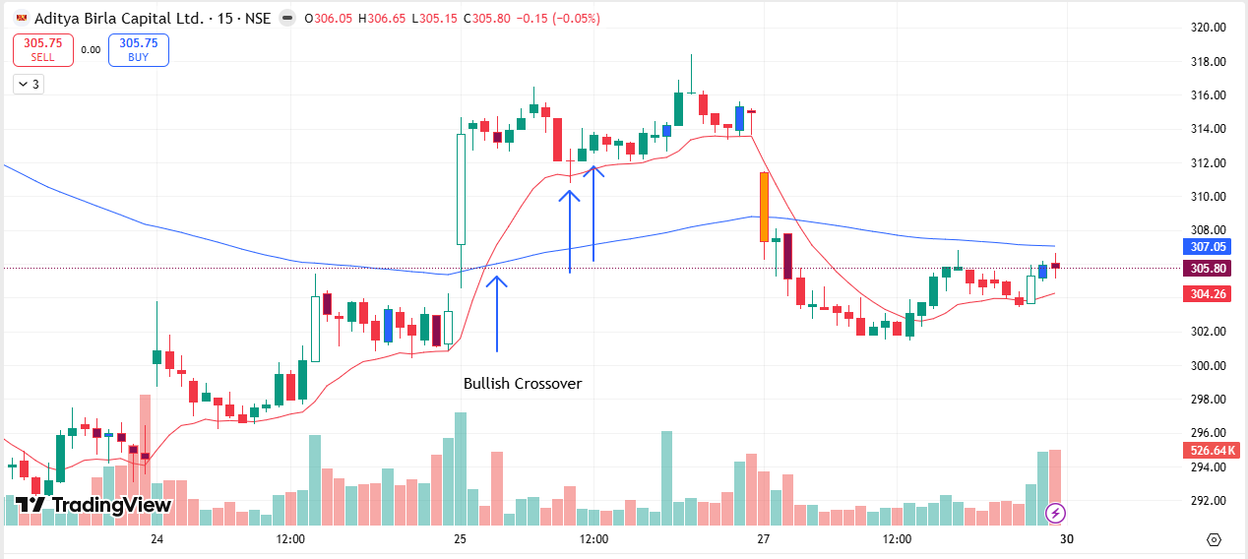
🔴 BEARISH SIGNAL --- BANDHANBNK

Nifty Bias : 🔴 SHORT — Aligned ✅
Crossover : 2026-03-27 09:45 (4 hours ago)
Pullback : 2026-03-27 13:15
High ₹150.1 ≥ EMA9(High) ₹149.92
Low ₹149.5 (breakdown level)
Confirm : 2026-03-27 13:30 (+1 candle)
Close ₹149.38 < Pullback Low ₹149.5 (body breakdown)
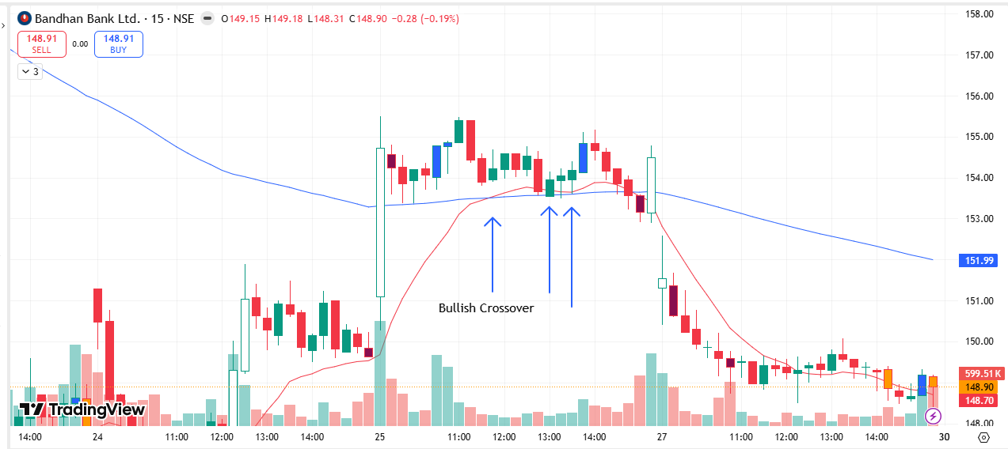
🔴 BEARISH SIGNAL --- BANKINDIA

Nifty Bias : 🔴 SHORT — Aligned ✅
Crossover : 2026-03-27 09:45 (4 hours ago)
Pullback : 2026-03-27 13:15
High ₹145.2 ≥ EMA9(High) ₹144.82
Low ₹144.56 (breakdown level)
Confirm : 2026-03-27 13:30 (+1 candle)
Close ₹144.33 < Pullback Low ₹144.56 (body breakdown)

🔴 BEARISH SIGNAL --- CDSL

Nifty Bias : 🔴 SHORT — Aligned ✅
Crossover : 2026-03-27 11:00 (3 hours ago)
Pullback : 2026-03-27 13:15
High ₹1186.6 ≥ EMA9(High) ₹1184.75
Low ₹1180.4 (breakdown level)
Confirm : 2026-03-27 13:30 (+1 candle)
Close ₹1179 < Pullback Low ₹1180.4 (body breakdown)

🔴 BEARISH SIGNAL --- DLF

Nifty Bias : 🔴 SHORT — Aligned ✅
Crossover : 2026-03-27 09:45 (4 hours ago)
Pullback : 2026-03-27 13:15
High ₹530.75 ≥ EMA9(High) ₹528.21
Low ₹527.75 (breakdown level)
Confirm : 2026-03-27 13:30 (+1 candle)
Close ₹527.7 < Pullback Low ₹527.75 (body breakdown)

🔴 BEARISH SIGNAL --- GMRAIRPORT

Nifty Bias : 🔴 SHORT — Aligned ✅
Crossover : 2026-03-27 10:30 (3 hours ago)
Pullback : 2026-03-27 13:15
High ₹88.99 ≥ EMA9(High) ₹88.6
Low ₹88.65 (breakdown level)
Confirm : 2026-03-27 13:30 (+1 candle)
Close ₹88.64 < Pullback Low ₹88.65 (body breakdown)

🔴 BEARISH SIGNAL --- IIFL

Nifty Bias : 🔴 SHORT — Aligned ✅
Crossover : 2026-03-27 09:45 (4 hours ago)
Pullback : 2026-03-27 12:45
High ₹453.85 ≥ EMA9(High) ₹451.94
Low ₹450.3 (breakdown level)
Confirm : 2026-03-27 13:30 (+3 candle)
Close ₹449.95 < Pullback Low ₹450.3 (body breakdown)

🔴 BEARISH SIGNAL --- INDUSINDBK

Nifty Bias : 🔴 SHORT — Aligned ✅
Crossover : 2026-03-27 10:30 (3 hours ago)
Pullback : 2026-03-27 13:00
High ₹801.7 ≥ EMA9(High) ₹800.14
Low ₹797.65 (breakdown level)
Confirm : 2026-03-27 13:30 (+2 candle)
Close ₹797.2 < Pullback Low ₹797.65 (body breakdown)

🔴 BEARISH SIGNAL --- INDIGO

Nifty Bias : 🔴 SHORT — Aligned ✅
Crossover : 2026-03-27 11:45 (2 hours ago)
Pullback : 2026-03-27 13:15
High ₹4172.8 ≥ EMA9(High) ₹4151.21
Low ₹4151 (breakdown level)
Confirm : 2026-03-27 13:30 (+1 candle)
Close ₹4149.3 < Pullback Low ₹4151 (body breakdown)

🔴 BEARISH SIGNAL --- JIOFIN

Nifty Bias : 🔴 SHORT — Aligned ✅
Crossover : 2026-03-27 10:30 (3 hours ago)
Pullback : 2026-03-27 13:15
High ₹233.75 ≥ EMA9(High) ₹233.5
Low ₹232.9 (breakdown level)
Confirm : 2026-03-27 13:30 (+1 candle)
Close ₹232.75 < Pullback Low ₹232.9 (body breakdown)

🔴 BEARISH SIGNAL --- KOTAKBANK

Nifty Bias : 🔴 SHORT — Aligned ✅
Crossover : 2026-03-27 10:15 (4 hours ago)
Pullback : 2026-03-27 13:15
High ₹365.7 ≥ EMA9(High) ₹365.53
Low ₹364.85 (breakdown level)
Confirm : 2026-03-27 13:30 (+1 candle)
Close ₹363.9 < Pullback Low ₹364.85 (body breakdown)

🔴 BEARISH SIGNAL --- LTF

Nifty Bias : 🔴 SHORT — Aligned ✅
Crossover : 2026-03-27 10:15 (4 hours ago)
Pullback : 2026-03-27 13:15
High ₹252.9 ≥ EMA9(High) ₹252.38
Low ₹251.75 (breakdown level)
Confirm : 2026-03-27 13:30 (+1 candle)
Close ₹251.65 < Pullback Low ₹251.75 (body breakdown)

🔴 BEARISH SIGNAL --- M&M

Nifty Bias : 🔴 SHORT — Aligned ✅
Crossover : 2026-03-27 12:15 (2 hours ago)
Pullback : 2026-03-27 12:45
High ₹3071.9 ≥ EMA9(High) ₹3066.88
Low ₹3057.6 (breakdown level)
Confirm : 2026-03-27 13:30 (+3 candle)
Close ₹3055.5 < Pullback Low ₹3057.6 (body breakdown)

🔴 BEARISH SIGNAL --- PFC

Nifty Bias : 🔴 SHORT — Aligned ✅
Crossover : 2026-03-25 14:15 (2 days ago)
Pullback : 2026-03-27 13:15
High ₹403.95 ≥ EMA9(High) ₹401.44
Low ₹402.3 (breakdown level)
Confirm : 2026-03-27 13:30 (+1 candle)
Close ₹401.35 < Pullback Low ₹402.3 (body breakdown)

🔴 BEARISH SIGNAL --- RBLBANK

Nifty Bias : 🔴 SHORT — Aligned ✅
Crossover : 2026-03-27 11:45 (2 hours ago)
Pullback : 2026-03-27 13:00
High ₹298.2 ≥ EMA9(High) ₹297.57
Low ₹297 (breakdown level)
Confirm : 2026-03-27 13:30 (+2 candle)
Close ₹296.05 < Pullback Low ₹297 (body breakdown)

🔴 BEARISH SIGNAL --- RECLTD

Nifty Bias : 🔴 SHORT — Aligned ✅
Crossover : 2026-03-27 10:30 (3 hours ago)
Pullback : 2026-03-27 13:15
High ₹323.55 ≥ EMA9(High) ₹322.22
Low ₹322.6 (breakdown level)
Confirm : 2026-03-27 13:30 (+1 candle)
Close ₹322.25 < Pullback Low ₹322.6 (body breakdown)

🔴 BEARISH SIGNAL --- SHRIRAMFIN

Nifty Bias : 🔴 SHORT — Aligned ✅
Crossover : 2026-03-27 10:15 (4 hours ago)
Pullback : 2026-03-27 13:15
High ₹915.9 ≥ EMA9(High) ₹915.46
Low ₹912 (breakdown level)
Confirm : 2026-03-27 13:30 (+1 candle)
Close ₹911.2 < Pullback Low ₹912 (body breakdown)

🔴 BEARISH SIGNAL --- TATACONSUM

Nifty Bias : 🔴 SHORT — Aligned ✅
Crossover : 2026-03-27 10:15 (4 hours ago)
Pullback : 2026-03-27 13:15
High ₹1052.6 ≥ EMA9(High) ₹1049.17
Low ₹1048 (breakdown level)
Confirm : 2026-03-27 13:30 (+1 candle)
Close ₹1047.3 < Pullback Low ₹1048 (body breakdown)

🔴 BEARISH SIGNAL --- TVSMOTOR

Nifty Bias : 🔴 SHORT — Aligned ✅
Crossover : 2026-03-27 11:00 (3 hours ago)
Pullback : 2026-03-27 12:45
High ₹3487.3 ≥ EMA9(High) ₹3479.54
Low ₹3477.4 (breakdown level)
Confirm : 2026-03-27 13:30 (+3 candle)
Close ₹3477.2 < Pullback Low ₹3477.4 (body breakdown)

🔴 BEARISH SIGNAL --- UNIONBANK

Nifty Bias : 🔴 SHORT — Aligned ✅
Crossover : 2026-03-27 11:00 (3 hours ago)
Pullback : 2026-03-27 13:00
High ₹175.28 ≥ EMA9(High) ₹174.71
Low ₹174.51 (breakdown level)
Confirm : 2026-03-27 13:30 (+2 candle)
Close ₹174.35 < Pullback Low ₹174.51 (body breakdown)

🔴 BEARISH SIGNAL --- BHEL

Nifty Bias : 🔴 SHORT — Aligned ✅
Crossover : 2026-03-27 11:00 (3 hours ago)
Pullback : 2026-03-27 13:30
High ₹257.25 ≥ EMA9(High) ₹257.18
Low ₹256.5 (breakdown level)
Confirm : 2026-03-27 13:45 (+1 candle)
Close ₹256.35 < Pullback Low ₹256.5 (body breakdown)

🔴 BEARISH SIGNAL --- CANBK

Nifty Bias : 🔴 SHORT — Aligned ✅
Crossover : 2026-03-27 10:00 (4 hours ago)
Pullback : 2026-03-27 13:15
High ₹131.96 ≥ EMA9(High) ₹131.73
Low ₹131.42 (breakdown level)
Confirm : 2026-03-27 13:45 (+2 candle)
Close ₹130.92 < Pullback Low ₹131.42 (body breakdown)

🔴 BEARISH SIGNAL --- CHOLAFIN

Nifty Bias : 🔴 SHORT — Aligned ✅
Crossover : 2026-03-27 10:45 (3 hours ago)
Pullback : 2026-03-27 13:15
High ₹1441.8 ≥ EMA9(High) ₹1436.86
Low ₹1435.6 (breakdown level)
Confirm : 2026-03-27 13:45 (+2 candle)
Close ₹1434.3 < Pullback Low ₹1435.6 (body breakdown)

🔴 BEARISH SIGNAL --- INDIANB

Nifty Bias : 🔴 SHORT — Aligned ✅
Crossover : 2026-03-27 12:00 (2 hours ago)
Pullback : 2026-03-27 13:15
High ₹882.55 ≥ EMA9(High) ₹879.78
Low ₹878.2 (breakdown level)
Confirm : 2026-03-27 13:45 (+2 candle)
Close ₹877.45 < Pullback Low ₹878.2 (body breakdown)

🔴 BEARISH SIGNAL --- IRFC

Nifty Bias : 🔴 SHORT — Aligned ✅
Crossover : 2026-03-27 10:30 (4 hours ago)
Pullback : 2026-03-27 13:00
High ₹93.55 ≥ EMA9(High) ₹93.21
Low ₹93 (breakdown level)
Confirm : 2026-03-27 13:45 (+3 candle)
Close ₹92.87 < Pullback Low ₹93 (body breakdown)

🟢 BULLISH SIGNAL --- NUVAMA

Nifty Bias : 🔴 SHORT — Counter Trend ⚠️
Crossover : 2026-03-24 13:30 (3 days ago)
Pullback : 2026-03-27 13:30
Low ₹1196.7 ≤ EMA9(Low) ₹1198.83
High ₹1202.3 (breakout level)
Confirm : 2026-03-27 13:45 (+1 candle)
Close ₹1207.3 > Pullback High ₹1202.3 (body breakout)

🔴 BEARISH SIGNAL --- POLYCAB

Nifty Bias : 🔴 SHORT — Aligned ✅
Crossover : 2026-03-27 10:15 (4 hours ago)
Pullback : 2026-03-27 13:00
High ₹7099 ≥ EMA9(High) ₹7055.05
Low ₹7070.5 (breakdown level)
Confirm : 2026-03-27 13:45 (+3 candle)
Close ₹7064.5 < Pullback Low ₹7070.5 (body breakdown)

🔴 BEARISH SIGNAL --- PRESTIGE

Nifty Bias : 🔴 SHORT — Aligned ✅
Crossover : 2026-03-27 09:30 (5 hours ago)
Pullback : 2026-03-27 13:15
High ₹1187.4 ≥ EMA9(High) ₹1182.22
Low ₹1179.2 (breakdown level)
Confirm : 2026-03-27 13:45 (+2 candle)
Close ₹1178.8 < Pullback Low ₹1179.2 (body breakdown)

🔴 BEARISH SIGNAL --- PHOENIXLTD

Nifty Bias : 🔴 SHORT — Aligned ✅
Crossover : 2026-03-27 10:45 (3 hours ago)
Pullback : 2026-03-27 13:15
High ₹1533 ≥ EMA9(High) ₹1527.69
Low ₹1523.6 (breakdown level)
Confirm : 2026-03-27 13:45 (+2 candle)
Close ₹1519.8 < Pullback Low ₹1523.6 (body breakdown)

🔴 BEARISH SIGNAL --- VEDL

Nifty Bias : 🔴 SHORT — Aligned ✅
Crossover : 2026-03-27 10:00 (4 hours ago)
Pullback : 2026-03-27 13:15
High ₹657.65 ≥ EMA9(High) ₹656.25
Low ₹654.65 (breakdown level)
Confirm : 2026-03-27 13:45 (+2 candle)
Close ₹653.6 < Pullback Low ₹654.65 (body breakdown)

🟢 BULLISH SIGNAL --- WIPRO

Nifty Bias : 🔴 SHORT — Counter Trend ⚠️
Crossover : 2026-03-27 12:15 (2 hours ago)
Pullback : 2026-03-27 13:30
Low ₹190.24 ≤ EMA9(Low) ₹190.43
High ₹191.16 (breakout level)
Confirm : 2026-03-27 13:45 (+1 candle)
Close ₹191.2 > Pullback High ₹191.16 (body breakout)

🔴 BEARISH SIGNAL --- AMBUJACEM

Nifty Bias : 🔴 SHORT — Aligned ✅
Crossover : 2026-03-27 10:30 (4 hours ago)
Pullback : 2026-03-27 13:15
High ₹414 ≥ EMA9(High) ₹413.05
Low ₹412.1 (breakdown level)
Confirm : 2026-03-27 14:00 (+3 candle)
Close ₹411.85 < Pullback Low ₹412.1 (body breakdown)

🔴 BEARISH SIGNAL --- BLUESTARCO

Nifty Bias : 🔴 SHORT — Aligned ✅
Crossover : 2026-03-27 11:45 (3 hours ago)
Pullback : 2026-03-27 13:45
High ₹1707.7 ≥ EMA9(High) ₹1703.9
Low ₹1703 (breakdown level)
Confirm : 2026-03-27 14:00 (+1 candle)
Close ₹1702.9 < Pullback Low ₹1703 (body breakdown)

🔴 BEARISH SIGNAL --- HDFCAMC

Nifty Bias : 🔴 SHORT — Aligned ✅
Crossover : 2026-03-27 10:00 (4 hours ago)
Pullback : 2026-03-27 13:45
High ₹2330.1 ≥ EMA9(High) ₹2325.06
Low ₹2324.1 (breakdown level)
Confirm : 2026-03-27 14:00 (+1 candle)
Close ₹2323.7 < Pullback Low ₹2324.1 (body breakdown)

🔴 BEARISH SIGNAL --- MANAPPURAM

Nifty Bias : 🔴 SHORT — Aligned ✅
Crossover : 2026-03-27 10:45 (4 hours ago)
Pullback : 2026-03-27 13:15
High ₹256.6 ≥ EMA9(High) ₹255.65
Low ₹255.25 (breakdown level)
Confirm : 2026-03-27 14:00 (+3 candle)
Close ₹254.8 < Pullback Low ₹255.25 (body breakdown)

🔴 BEARISH SIGNAL --- MOTHERSON

Nifty Bias : 🔴 SHORT — Aligned ✅
Crossover : 2026-03-27 10:15 (4 hours ago)
Pullback : 2026-03-27 13:30
High ₹110.95 ≥ EMA9(High) ₹110.78
Low ₹110.59 (breakdown level)
Confirm : 2026-03-27 14:00 (+2 candle)
Close ₹110.58 < Pullback Low ₹110.59 (body breakdown)

🔴 BEARISH SIGNAL --- SUZLON

Nifty Bias : 🔴 SHORT — Aligned ✅
Crossover : 2026-03-27 11:15 (3 hours ago)
Pullback : 2026-03-27 13:45
High ₹41.36 ≥ EMA9(High) ₹41.34
Low ₹41.18 (breakdown level)
Confirm : 2026-03-27 14:00 (+1 candle)
Close ₹41.16 < Pullback Low ₹41.18 (body breakdown)

🔴 BEARISH SIGNAL --- YESBANK

Nifty Bias : 🔴 SHORT — Aligned ✅
Crossover : 2026-03-27 10:30 (4 hours ago)
Pullback : 2026-03-27 13:15
High ₹18.1 ≥ EMA9(High) ₹18.1
Low ₹18.04 (breakdown level)
Confirm : 2026-03-27 14:00 (+3 candle)
Close ₹18.03 < Pullback Low ₹18.04 (body breakdown)

🔴 BEARISH SIGNAL --- BAJAJ-AUTO

Nifty Bias : 🔴 SHORT — Aligned ✅
Crossover : 2026-03-27 10:15 (4 hours ago)
Pullback : 2026-03-27 13:45
High ₹8973.5 ≥ EMA9(High) ₹8939.72
Low ₹8945 (breakdown level)
Confirm : 2026-03-27 14:15 (+2 candle)
Close ₹8941 < Pullback Low ₹8945 (body breakdown)

🔴 BEARISH SIGNAL --- BIOCON

Nifty Bias : 🔴 SHORT — Aligned ✅
Crossover : 2026-03-27 11:30 (3 hours ago)
Pullback : 2026-03-27 13:45
High ₹373.9 ≥ EMA9(High) ₹372.9
Low ₹371.95 (breakdown level)
Confirm : 2026-03-27 14:15 (+2 candle)
Close ₹371.05 < Pullback Low ₹371.95 (body breakdown)

🔴 BEARISH SIGNAL --- NYKAA

Nifty Bias : 🔴 SHORT — Aligned ✅
Crossover : 2026-03-27 11:45 (3 hours ago)
Pullback : 2026-03-27 14:00
High ₹240.15 ≥ EMA9(High) ₹239.99
Low ₹239.4 (breakdown level)
Confirm : 2026-03-27 14:15 (+1 candle)
Close ₹239.25 < Pullback Low ₹239.4 (body breakdown)

🔴 BEARISH SIGNAL --- IDFCFIRSTB

Nifty Bias : 🔴 SHORT — Aligned ✅
Crossover : 2026-03-27 10:45 (4 hours ago)
Pullback : 2026-03-27 14:00
High ₹61.95 ≥ EMA9(High) ₹61.94
Low ₹61.65 (breakdown level)
Confirm : 2026-03-27 14:15 (+1 candle)
Close ₹61.62 < Pullback Low ₹61.65 (body breakdown)

🔴 BEARISH SIGNAL --- POWERGRID

Nifty Bias : 🔴 SHORT — Aligned ✅
Crossover : 2026-03-25 13:30 (2 days ago)
Pullback : 2026-03-27 13:30
High ₹297.05 ≥ EMA9(High) ₹296.32
Low ₹296.2 (breakdown level)
Confirm : 2026-03-27 14:15 (+3 candle)
Close ₹295.75 < Pullback Low ₹296.2 (body breakdown)

🔴 BEARISH SIGNAL --- SBICARD

Nifty Bias : 🔴 SHORT — Aligned ✅
Crossover : 2026-03-27 11:45 (3 hours ago)
Pullback : 2026-03-27 13:30
High ₹685 ≥ EMA9(High) ₹684.62
Low ₹679.65 (breakdown level)
Confirm : 2026-03-27 14:15 (+3 candle)
Close ₹672.95 < Pullback Low ₹679.65 (body breakdown)

🔴 BEARISH SIGNAL --- EICHERMOT

Nifty Bias : 🔴 SHORT — Aligned ✅
Crossover : 2026-03-27 10:30 (4 hours ago)
Pullback : 2026-03-27 13:45
High ₹6852.5 ≥ EMA9(High) ₹6833.27
Low ₹6832 (breakdown level)
Confirm : 2026-03-27 14:30 (+3 candle)
Close ₹6830.5 < Pullback Low ₹6832 (body breakdown)

🔴 BEARISH SIGNAL --- HDFCBANK

Nifty Bias : 🔴 SHORT — Aligned ✅
Crossover : 2026-03-27 09:45 (5 hours ago)
Pullback : 2026-03-27 13:45
High ₹762 ≥ EMA9(High) ₹761.64
Low ₹759.5 (breakdown level)
Confirm : 2026-03-27 14:30 (+3 candle)
Close ₹758.1 < Pullback Low ₹759.5 (body breakdown)

🔴 BEARISH SIGNAL --- HUDCO

Nifty Bias : 🔴 SHORT — Aligned ✅
Crossover : 2026-03-27 11:00 (4 hours ago)
Pullback : 2026-03-27 13:45
High ₹170.32 ≥ EMA9(High) ₹170.12
Low ₹169.55 (breakdown level)
Confirm : 2026-03-27 14:30 (+3 candle)
Close ₹169.07 < Pullback Low ₹169.55 (body breakdown)

🔴 BEARISH SIGNAL --- SONACOMS

Nifty Bias : 🔴 SHORT — Aligned ✅
Crossover : 2026-03-27 10:45 (4 hours ago)
Pullback : 2026-03-27 14:15
High ₹492 ≥ EMA9(High) ₹491.42
Low ₹490.7 (breakdown level)
Confirm : 2026-03-27 14:30 (+1 candle)
Close ₹490.25 < Pullback Low ₹490.7 (body breakdown)

🔴 BEARISH SIGNAL --- UNOMINDA

Nifty Bias : 🔴 SHORT — Aligned ✅
Crossover : 2026-03-27 11:30 (3 hours ago)
Pullback : 2026-03-27 14:00
High ₹1053.4 ≥ EMA9(High) ₹1053.32
Low ₹1050 (breakdown level)
Confirm : 2026-03-27 14:30 (+2 candle)
Close ₹1049.7 < Pullback Low ₹1050 (body breakdown)

🔴 BEARISH SIGNAL --- 360ONE

Nifty Bias : 🔴 SHORT — Aligned ✅
Crossover : 2026-03-20 14:45 (7 days ago)
Pullback : 2026-03-27 14:00
High ₹988.1 ≥ EMA9(High) ₹981.59
Low ₹983.9 (breakdown level)
Confirm : 2026-03-27 14:45 (+3 candle)
Close ₹979.2 < Pullback Low ₹983.9 (body breakdown)

🔴 BEARISH SIGNAL --- COLPAL

Nifty Bias : 🔴 SHORT — Aligned ✅
Crossover : 2026-03-27 14:00 (an hour ago)
Pullback : 2026-03-27 14:30
High ₹1899.9 ≥ EMA9(High) ₹1895.14
Low ₹1889.9 (breakdown level)
Confirm : 2026-03-27 14:45 (+1 candle)
Close ₹1884.8 < Pullback Low ₹1889.9 (body breakdown)

🔴 BEARISH SIGNAL --- CONCOR

Nifty Bias : 🔴 SHORT — Aligned ✅
Crossover : 2026-03-27 10:30 (5 hours ago)
Pullback : 2026-03-27 14:45
High ₹438.5 ≥ EMA9(High) ₹437.72
Low ₹436.5 (breakdown level)
Confirm : 2026-03-27 15:00 (+1 candle)
Close ₹435.45 < Pullback Low ₹436.5 (body breakdown)

🔴 BEARISH SIGNAL --- ICICIGI

Nifty Bias : 🔴 SHORT — Aligned ✅
Crossover : 2026-03-27 10:45 (5 hours ago)
Pullback : 2026-03-27 14:45
High ₹1758.9 ≥ EMA9(High) ₹1749.47
Low ₹1751.5 (breakdown level)
Confirm : 2026-03-27 15:00 (+1 candle)
Close ₹1748.9 < Pullback Low ₹1751.5 (body breakdown)

🔴 BEARISH SIGNAL --- ICICIPRULI

Nifty Bias : 🔴 SHORT — Aligned ✅
Crossover : 2026-03-25 13:15 (2 days ago)
Pullback : 2026-03-27 14:15
High ₹532.3 ≥ EMA9(High) ₹531.89
Low ₹531.2 (breakdown level)
Confirm : 2026-03-27 15:00 (+3 candle)
Close ₹530.1 < Pullback Low ₹531.2 (body breakdown)

🔴 BEARISH SIGNAL --- IRCTC

Nifty Bias : 🔴 SHORT — Aligned ✅
Crossover : 2026-03-27 10:00 (5 hours ago)
Pullback : 2026-03-27 14:15
High ₹513.15 ≥ EMA9(High) ₹512.71
Low ₹512.1 (breakdown level)
Confirm : 2026-03-27 15:00 (+3 candle)
Close ₹510.65 < Pullback Low ₹512.1 (body breakdown)

🔴 BEARISH SIGNAL --- MARUTI

Nifty Bias : 🔴 SHORT — Aligned ✅
Crossover : 2026-03-27 10:15 (5 hours ago)
Pullback : 2026-03-27 14:15
High ₹12418 ≥ EMA9(High) ₹12412.85
Low ₹12381 (breakdown level)
Confirm : 2026-03-27 15:00 (+3 candle)
Close ₹12361 < Pullback Low ₹12381 (body breakdown)

🔴 BEARISH SIGNAL --- MFSL

Nifty Bias : 🔴 SHORT — Aligned ✅
Crossover : 2026-03-25 15:00 (2 days ago)
Pullback : 2026-03-27 14:30
High ₹1568.3 ≥ EMA9(High) ₹1560.91
Low ₹1559 (breakdown level)
Confirm : 2026-03-27 15:00 (+2 candle)
Close ₹1558.3 < Pullback Low ₹1559 (body breakdown)

🔴 BEARISH SIGNAL --- NCC

Nifty Bias : 🔴 SHORT — Aligned ✅
Crossover : 2026-03-27 10:00 (5 hours ago)
Pullback : 2026-03-27 14:15
High ₹137.64 ≥ EMA9(High) ₹136.63
Low ₹136.67 (breakdown level)
Confirm : 2026-03-27 15:00 (+3 candle)
Close ₹136.49 < Pullback Low ₹136.67 (body breakdown)

🔴 BEARISH SIGNAL --- SAIL

Nifty Bias : 🔴 SHORT — Aligned ✅
Crossover : 2026-03-27 11:45 (4 hours ago)
Pullback : 2026-03-27 14:15
High ₹148.6 ≥ EMA9(High) ₹148.05
Low ₹146.73 (breakdown level)
Confirm : 2026-03-27 15:00 (+3 candle)
Close ₹146.3 < Pullback Low ₹146.73 (body breakdown)

🟢 BULLISH SIGNAL --- FEDERALBNK

Nifty Bias : 🔴 SHORT — Counter Trend ⚠️
Crossover : 2026-03-27 12:45 (3 hours ago)
Pullback : 2026-03-27 14:45
Low ₹267.45 ≤ EMA9(Low) ₹267.55
High ₹268.2 (breakout level)
Confirm : 2026-03-27 15:00 (+1 candle)
Close ₹269.45 > Pullback High ₹268.2 (body breakout)

🔴 BEARISH SIGNAL --- TMPV

Nifty Bias : 🔴 SHORT — Aligned ✅
Crossover : 2026-03-27 10:00 (6 hours ago)
Pullback : 2026-03-27 14:45
High ₹303.65 ≥ EMA9(High) ₹303.49
Low ₹302.4 (breakdown level)
Confirm : 2026-03-27 15:15 (+2 candle)
Close ₹302.35 < Pullback Low ₹302.4 (body breakdown)

📊 TRADING SUMMARY
━━ ALL TRADES (27-Mar) ━━━━━━━━━━━━━━━━━━━━
Total Signals | 153
Taken Trades | 08
Not Taken | 145
Balance | Rs. 1,09,75,128.40
Current Balance | Rs. 1,09,30,373.36

━━ TODAY'S LIVE TRADING (27-Mar) ━━━━━━━━━━━━━━━━━━━━
Total | 8
Completed | 08
Wins ✅ | 6
Losses ❌ | 2
Open ⏳ | 0
Win Rate | 75.0%
Net P/L | +Rs. 2,560.50 , +0.00 pts
Brokerage | Rs. 320.00
Taxes & Fees | Rs. 1204.50

━━ ALL-TIME LIVE TRADING ━━━━━━━━━━━━━━━━━━━━
Completed | 27
Wins ✅ | 11
Losses ❌ | 16
Open ⏳ | 4
Win Rate | 40.7%
Net P/L | -Rs. 44,755.04 , -88,580.00 pts
Brokerage | Rs. 1840.00
Taxes & Fees | Rs. 7255.58

━━ TODAY'S BACKTEST (27-Mar) ━━━━━━━━━━━━━━━━━━━━
Signals Today | 153
Resolved | 133
TARGET HIT ✅ | 63
SL HIT ❌ | 70
Open ⏳ | 20
Win Rate | 47.4%
Total PnL | -415.32 pts

━━ ALL-TIME BACKTEST SUMMARY ━━━━━━━━━━━━━━━━━━━━
Total Signals | 433
TARGET HIT ✅ | 214
SL HIT ❌ | 196
Open ⏳ | 23
Win Rate | 52.2%
Total PnL | +1,059.41 pts

🤖 TRADE BEHAVIOUR ANALYSIS
✅ Trades Taken — What signals fired:
1. NAUKRI — Bullish crossover, counter-trend to Nifty. Entry ₹1005.3, SL ₹999.
2. MCX — Bullish crossover, counter-trend to Nifty. Entry ₹2472.6, SL ₹2456.1.
3. LODHA — Bearish crossover, aligned with Nifty bias. Entry ₹723.7, SL ₹741.85.
4. PETRONET — Bearish crossover, aligned with Nifty bias. Entry ₹248.4, SL ₹251.
5. DIVISLAB — Bearish crossover, aligned with Nifty bias. Entry ₹6008.5, SL ₹6052.
6. BEL — Bearish crossover, aligned with Nifty bias. Entry ₹411.7, SL ₹413.45.
7. MAZDOCK — Bearish crossover, aligned with Nifty bias. Entry ₹2210.8, SL ₹2228.
8. TORNTPOWER — Bearish crossover, aligned with Nifty bias. Entry ₹1384.2, SL ₹1391.8.
9. MCX — Bearish crossover, aligned with Nifty bias. Entry ₹2407.5, SL ₹2423.5.
⛔ Trades Not Taken (144 signals skipped):
Counter-trend to Nifty bias — skipped (73): ASTRAL, CAMS, HFCL, IEX, KPITTECH, LICHSGFIN, NHPC, NATIONALUM, ONGC, OFSS, SUNPHARMA, SYNGENE, TATAELXSI, TATATECH, UPL, AUROPHARMA, DMART, BSE, DRREDDY, LUPIN, NMDC, NTPC, NESTLEIND, SAMMAANCAP, ALKEM, BHARTIARTL, FORTIS, HCLTECH, INFY, MUTHOOTFIN, PERSISTENT, PPLPHARMA, TECHM, TORNTPHARM, AXISBANK, GRASIM, HINDZINC, POWERINDIA, M&M, RVNL, SHREECEM, SRF, ULTRACEMCO, APLAPOLLO, AUBANK, APOLLOHOSP, BAJFINANCE, COFORGE, ETERNAL, HINDPETRO, KALYANKJIL, LT, MANKIND, MAXHEALTH, OBEROIRLTY, TATASTEEL, GLENMARK, PNBHOUSING, FEDERALBNK, DALBHARAT, LTM, MARICO, MPHASIS, VOLTAS, DELHIVERY, KAYNES, TIINDIA, ANGELONE, JINDALSTEL, LAURUSLABS, NUVAMA, WIPRO, FEDERALBNK
Aligned but not entered (71): BDL, COALINDIA, GAIL, SBILIFE, CYIENT, GODREJCP, IDEA, ABB, BOSCHLTD, HAL, IGL, TATAPOWER, ADANIGREEN, ABCAPITAL, BANDHANBNK, BANKINDIA, CDSL, DLF, GMRAIRPORT, IIFL, INDUSINDBK, INDIGO, JIOFIN, KOTAKBANK, LTF, M&M, PFC, RBLBANK, RECLTD, SHRIRAMFIN, TATACONSUM, TVSMOTOR, UNIONBANK, BHEL, CANBK, CHOLAFIN, INDIANB, IRFC, POLYCAB, PRESTIGE, PHOENIXLTD, VEDL, AMBUJACEM, BLUESTARCO, HDFCAMC, MANAPPURAM, MOTHERSON, SUZLON, YESBANK, BAJAJ-AUTO, BIOCON, NYKAA, IDFCFIRSTB, POWERGRID, SBICARD, EICHERMOT, HDFCBANK, HUDCO, SONACOMS, UNOMINDA, 360ONE, COLPAL, CONCOR, ICICIGI, ICICIPRULI, IRCTC, MARUTI, MFSL, NCC, SAIL, TMPV
📝 94% of today's signals were not acted on. 73 were counter-trend — correct discipline to avoid. 71 aligned signals were not taken — review if entry was missed or risk was too high.

